How can Illumination Techniques enhance the level design and emotional response in games - Report
Mastres degree final year reasearch paper
Filip Lichonczak
2024
Table of Contents
Introduction 3
Abstract 3
Study purpose 3
Literature Review 3
What are illumination techniques 3
Tension Manipulation 6
The Art of Film Lighting: Creating Atmosphere and Mood on Screen 9
Illumination techniques in games design 9
Player types 9
Methodology 9
Sampling method 10
Data collection method 10
Findings 10
Conclusion 11
Future Research 11
Introduction 14
Introduction to research 14
The need to review 14
Describing research question in detail 14
What the reader gains from this review 14
Presenting study methods 14
Specifying the direction of research 14
Describing literature review and its criteria 14
Reporting data collection methods 15
Reporting results 15
The primary studies analysed 15
Experimental conditions used 16
The observed results 18
Participant feedback 29
The results 33
Subgroup results 33
Discussing the results 34
Additional work 34
References 38

Introduction

Abstract
This study aims to explore the illumination techniques in games environmental art, illumination techniques in live action movies and animations to discover what and how they can be used in matter of games level design to create more interesting and immersive player experience. It will also explore the subject of building emotional responses.

Study purpose
The aim of the project it to research illumination techniques and how they are supposed to be used correctly. Additionally, the research shows how these techniques can be used in a matter of level design and building emotional responses. The techniques should allow for tension manipulation. Both tension and building emotions are expected to be used in building player guidance.
During the project, researcher will analyse illumination techniques and how they potentially can be used in matter of the level design. The gained knowledge will be used to in building the first-person game experience that will be used for testing.
After Testing the participants will be asked to fill anonymous questionnaire and describe their experiences.
Collected responses will be used for the conclusion in the project report to describe the final findings.

Literature Review

What are illumination techniques
Illumination techniques are the base set of rules used to define the base and correct form of illumination in the industry. In his article (Illumination Techniques, n.d.) author describes basic illumination techniques, which are: lighting, diffuse lighting, bright field lighting and dark field lighting.
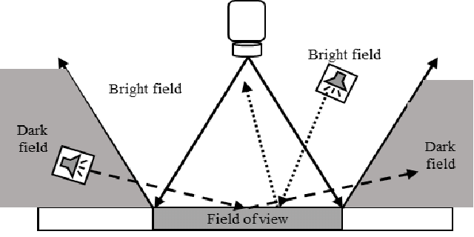
Back lighting is being described as element that generates instant contrast by creation of the silhouettes against a bright background. Author describes common usage of this technique in detecting the presence or absence of the object or in orientating or measuring the object. As an improvement author suggests using monochrome light (such as red, blue or green) with light polarization for more precise edge detection.
(Bayer, 2010)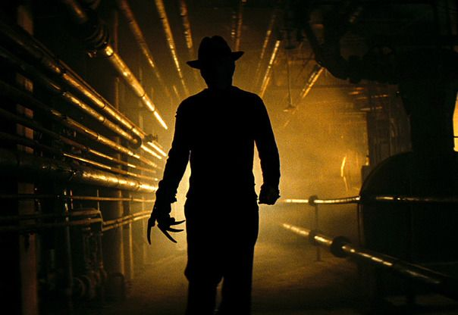
Diffuse Lighting - according to the author, it is commonly being used in a situation when specular or reflective objects need to be illuminated. Despite many techniques of diffuse lighting author introduces the basic ones. The most common technique uses hemispherical dome or cylinder to effectively illuminate curved and specular surfaces.
For the flat objects the one -axis light sources shout be used. They are being more effective at enhancing details visible on the flat objects. Moreover, with this technique instead of rejecting or avoiding the specular glare it can be used if isolated, to define the feature of interest.
Finally, author point that in other to create better effect with diffuse lights, light sources should be close to the objects, especially with the dome-variety of the illumination.
(Magazine i Video Gear, 2015)
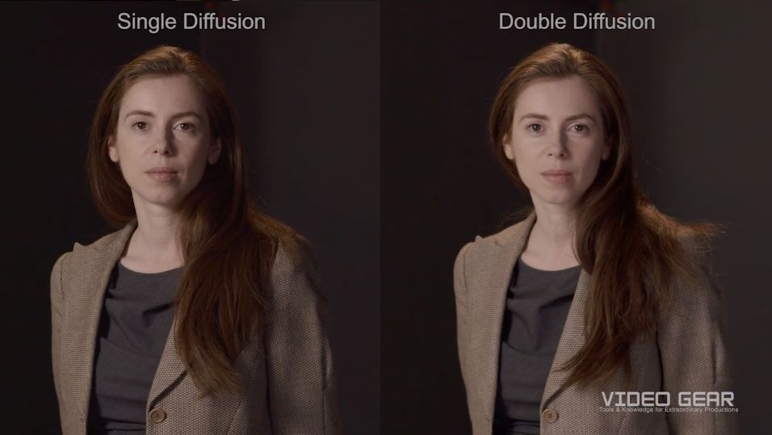
Dark Field Lighting
The usage of dark field lighting is relying on using light sources at low angle. They can reflect small imperfections and surrounding objects. A good example of the dark field lighting are car headlights.
The effective usage of this technique relies on fact that most of the light fall on the reflective surface. Otherwise, the light would illuminate the scene and create the glare. The base objective of the technique is to create the phenomenon where small amount of the light that is being reflected from the object and then enters the camera.
Dark Filed lighting has multiple types, in which we can find linear, circular and directional lights. Due to the low and nature of this technique it requires closer proximity to achieve good results.
(Mueller, 2012)

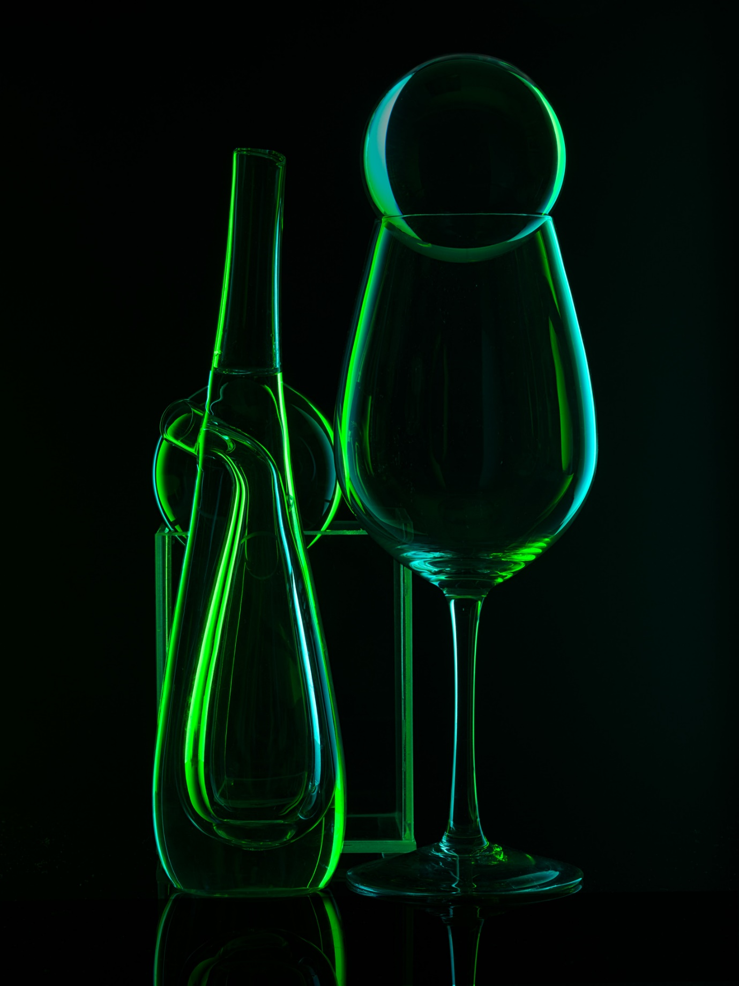

Tension Manipulation
According to the author (Magy Seif El-Nasr, 2007), the lighting pattern can be defined as a configuration of the principal elements of the light and its relation, that build a specific effect on the player or the viewer. That means with the proper configuration of lights, designer create can create different effects that will affect the viewer. This approach is commonly used in filmic media and live performances like theatres but also be used within digital technologies, like game industry.
Author points two basic types of the lighting patterns commonly used in the film industry.
Colour manipulation sustained over time – according to the author lack of change escalates the tension projected on the image or scene.
Colour pattern variations over time - the variation in a specific colour or pattern can increase to decrease the tension.
Contrasts and shadows
The same author mentions some techniques that might affect the tension by using contrasts and shadows.
To increase the tension, the participant should be presented with the low contrast followed by hight contrast image, low affinity of colour followed by high affinity of colour or long exposure to high contrast.
To release the tension author present techniques where participants should be presented with high contrast images followed by low contrast images or high affinity colour followed by low affinity colour.
All the techniques presented can also be applied to the brightness, contrast, warmth of the colour.
The above theories seem to be confirmed by article (Sellin, 2013). In her work author describe the illumination techniques and the basic art theory.
Author describes the techniques used in the Dario Argento’s “Suspiria” where at the beginning of the movie the main character is being shown in two colours of the light– red and blue. The effect created in this scene according to the author should create physical response by visualising the protagonist emotions of complacency and terror, and result with building the feeling of chaos.
The director of the movie is constantly using red and blue lighting to show emotions of the character, by assigning them accordingly to the terror or vulnerability. This results sometimes with creation of the chaos that is additionally building the tension.
(Jackson, 2018)
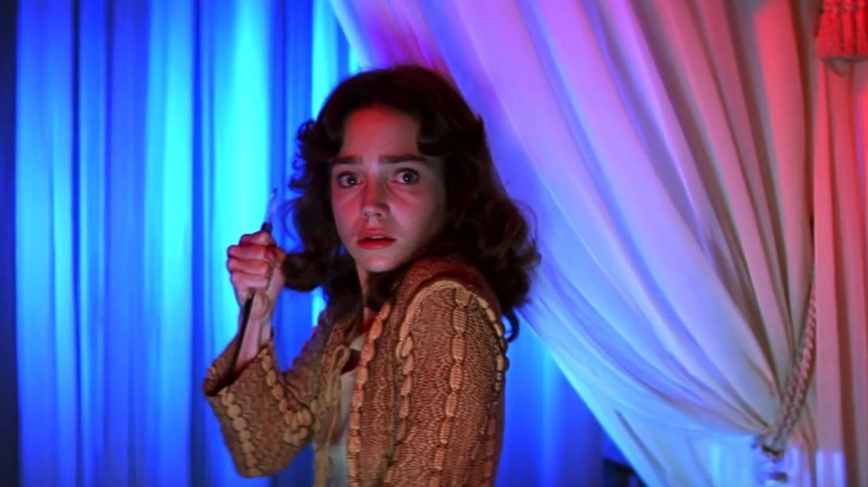
Creation feeling of chaos
Chaos in movies can be created in many ways. In the article (Kleinloog) author describe illumination techniques in movie production that can help with building “dynamic” of the scene and chaos. Authors give examples of using low lighting and using big number of shadows to create the dramatic look of the scene. This solution is commonly used in the horror games and thriller movies to create the tension. The same technique is capable of creation chaos by making details less visible and by obscuring the details of the scene.
Additionally, author (Peach, How can you use lighting to create chaos or confusion in a film?, brak daty) describe how more intense lights used for key illumination are capable of creation confusion. It is achieved by overexposing the scene, what makes hard to distinguish the colours, shapes and depth of the objects visible on the scene.
One of the most common techniques, that is also being describe by authors, are strobe lights. The rapidly flashing lights that create the “flickering” effect, that can be used to visually show the dynamic, energetic and chaotic aspect of the scene. Author (Almoqati, brak daty) also give example, where the technique is being used to disturb the motion, what makes it harder for the viewer to follow the action of the scene.
(Peach, How can you use lighting to create chaos or confusion in a film? - Colorful lighting, brak daty) also refer to the colours of lights, here they are usually being used to create more expressive environments. The technique allows for manipulation of the colour what might change how it’s being perceived by the viewer.
These techniques can be confirmed by article (Haus, 2020). Author not only provides description of the theatre illumination but also associate the techniques with the mood and emotional responses they might create. An interesting example technique is usage of spotlight, where author explains how focusing the light on single object can create the intense, dramatic feeling by highlighting specific object, character or movement.

The Art of Film Lighting: Creating Atmosphere and Mood on Screen
In the article (Films, 2023) created by CleverStreet Films author describes the various illumination techniques used in performances and screenplay. They point out that the correct lighting can make or break the scene, establish mood and therefore build emotional responses.
The primary method described was establishing the basics of film lighting by using:
- Key lighting, that is the primary light source of the scene and usually the brightest
- Fill lighting, that softens the shadows created by the key lighting
- Back lighting, that create the silhouette, to separate object from background
Author also describes creation of atmosphere with the lighting by using contrast and brightness of lights; and emotional responses created by intensity of the light, colour and shadows. The film lighting is being described as a constant change in colours, contrast and shadows that can elevate the visual experience and build or change emotional responses.

Illumination techniques in games design
In her work (Magy Seif El-Nasr, 2007) author describes something named as Expressive Lighting Engine (ELE). It is a dynamic and intelligent system what’s role is to analyse the current state of game and player and edit the lighting to support the desired experience.
To accomplish this ELE is using mathematical rules based on the study of films and theatre lighting techniques, to select light sources and adjust their position, colour and angles to match to the defined rules.
As an example, author refer to the demo of the system where users could experience the same environment in static lighting and the second with dynamic lighting that used saturation as a function of danger. Based on the responses author pointed that dynamic lighting provided much more aesthetically pleasing experience however it also provided ways to identify danger quicker for more experienced players. Additionally, some participant seemed to be disturbed by the lighting. That resulted with conclusion that dynamic lighting might not be best solution for fast paced gameplay (like First Person Shooters) but might be more beneficial in gameplay that takes advantage of emotional responses.
The paper however does not consider different type of the players, where some of them might be attracted to combat or danger. That suggest that the system should be even more dynamic to first identify the rules of the lighting that might attract the player and later use them in the actual gameplay with bigger effectiveness.

Player types
Because different types, players might perform different actions or be guided by different things. In his article Richard Bartle classifies players in four categories: killer, achiever, explorer and socialiser. It is a classification of video game players based on a Richard Bartle’s paper according to their preferred actions within the game. This suggest that different factors and techniques of the illumination might attract different types of the players.

Methodology
The purpose of this paper is to explore illumination techniques used in live action movie production, theatres, photography and animation or even paintings and to evaluate if they can be used in the matter of the games level design. The paper and research will focus mainly on emotion creation and tension manipulation and how it can be used to navigate the player around the environment.

Sampling method
The playtest will be performed with participants of different genders and experience with games or move creation to provide generalised results, that might be used in forming conclusion.
The participants will be asked to play/participate in two sessions. The dual-session playtest approach is innovative and well-thought-out, aiming to measure the effectiveness of different lighting techniques based on player feedback.
The first purpose is to evaluate what illumination techniques are most effective / noticeable by the player. The second one will relate to the second playtest session. Because different types of players (those who are attracted to light/safety or those attracted to darkness/mystery or danger)
The second playtest session will load correct type of the illumination based on the result from first playtest session. If player was more likely to choose illumination techniques associated with low tension and safety, they will be presented with those type of lighting in the level. This playtest will have a form of the maze where player will be guided by the most efficient techniques from first playtest. During this playtest the time needed to complete maze might be measured to evaluate the success of the experiment.
The questionnaire will have questions related to the player type. This information will be given after solving Bartle Test of Gamer Psychology. The next section will include the question about first testing environment. At this stage it will be possible to evaluate the efficiency of the techniques, or which one attract players the most. The results could be also compared with the result of player type test to create the subgroups, what might provide additional insight what is attracting the specific player types. Third part of the questionnaire will include questions related to the maze. Player will be asked to provide time of completion that will be used for defining general success or failure of the experiment. Additionally, participants will be asked if they noticed the patter in form of lighting that helped them to go through the environment. The last part will be plainly related to the player experience where participants will be able to express their feelings during the test or if they got confused.

Data collection method
After each playtest session players will be asked to fill the anonymous questionnaire with the chosen results/ path and time needed to complete the playtest. The result will be stored in secured Microsoft cloud storage (of the student university account).
The collected results will include not only the questionnaire itself but also screenshots from the playtest environment that will support the responses.

Findings
Based on the gathered materials, it seems that there are methods to build specific responses in human that might be used not only for building emotional responses but also for the guidance in matter of the game design.
Such solution would require analysing and testing basic techniques to check which one of them will be the most effective. The work should start with setting the base lighting to create light fields and dark fields that will allow for creation basic emotional responses.
To build on the base lighting one can manipulate the contrast, brightness, temperature of lights and colour saturation to enhance the responses created with the base technique but also to manipulate the tension.
Additionally, there are specific techniques that might be used to change the perception over the scene, and therefore the response of the viewer. One of them is shadow manipulation. It seems that using longer, obscured shadows can be used to distort the field of vision of the viewer.
Moreover, using specific colours or rapidly changing, blinking lights should be able to create the sensation of the scene being more dynamic or even chaotic.

Conclusion
This paper was created to explore the subject of the illumination techniques used in film production, theatres and photography that are building emotional responses and test if they can be used and with what effectiveness in the matter of the games level design. To do so, the base techniques were clarified, and multiple techniques used for building emotional responses were explored and described with showing the desired effect. Additionally, the paper describes the limitations related to the type of the players that might be essential for build effective illumination system used for guiding the player and explore the subject of Expressional Lighting Engine that might prevent it with dynamically changed lights. Taken together, this paper highlights the base knowledge of the illumination techniques and emotional responses that they might create what should allow for creation of the illumination that can change and therefore guide player with emotional responses.

Future Research
The research tests the base functionality of the techniques. Therefore, it can be extended.
The environment created for testing the techniques and their effects does not include the props. The future research could check if the same effect can be repeated within more complex environment with the same effect.
Additionally, interesting subject would be mixing different techniques to check if in increase their property of building emotion and changing tension. It should also check how many techniques could be used together before creation chaos.

2024
How can Illumination Techniques enhance the level design and emotional response in games - Report
Mastres degree final year reasearch paper
Filip Lichonczak
Table of Contents
Introduction 2
Introduction to research 2
The need to review 2
Describing research question in detail 2
What the reader gains from this review 2
Presenting study methods 2
Specifying the direction of research 2
Describing literature review and its criteria 2
Reporting data collection methods 3
Reporting results 3
The primary studies analysed 3
Experimental conditions used 4
The observed results 7
Participant feedback 19
The results 22
Subgroup results 23
Discussing the results 24

Introduction

Introduction to research
This research describes techniques used in movie production, theatre and photography, to identify those that are capable of manipulation viewer’s tension and to check if they can be used in game design and level design.

The need to review
The need of review of the subject is to find out if those illumination techniques can be used in the matter of game and level design. Additional target is to evaluate how effective those techniques can be.

Describing research question in detail
The key objective of this paper and report is to identify the techniques used to create specific impression, emotional response or effect that are used in movie and animation production, theatre or photography and to check if they can be recreated in game engine and successfully used as a gameplay element like guidance method.

What the reader gains from this review
Based on the research, reader can find out about the illumination techniques, how to set up the base lighting and what properties of the lighting can be changed to create different player responses. Additionally, reader will be able to evaluate the effectiveness of the specific techniques and their limitation while using in unreal engine.

Presenting study methods

Specifying the direction of research
Because of the iterative approach the research was divided into multiple stage.
- Research of the techniques and simple testing in Unreal Engine
- The Bartle Test of Gamer Psychology – evaluating what might attract different types of players
- First testing environment where participant will make their choices on preferred illumination. The result would be compared with the Bartle Test.
- Two version of the Second testing environment, that will test the functionality and effectiveness in matter of guidance of the participant
- Concluding the result

Describing literature review and its criteria
To identify the resources that are relevant to this work, key words were used. The keywords include among others:
- Games Lighting
- Base lighting techniques
- Lighting and tension
- Building emotional responses
- Movie lighting techniques
- Theatre lighting techniques
- Photography lighting techniques
- Animation lighting techniques
The collected materials were reviewed by reading abstract and conclusion to evaluate if the material is relevant to the project. All the materials that did not match the criteria were discarded.

Reporting data collection methods
The date will be collected via anonymous Microsoft questionnaire. Participants will answer the question about the testing environments and player type test. Additionally in player experience section participant will be able to provide screenshots to support their opinion about feature.

Reporting results

The primary studies analysed
Based on performed research, the following conclusion can be drawn.

Lack of change
The participant/viewer should not be exposed to the techniques (illumination) for long period of time, unless it’s necessary. The long exposure can cause the increasing the tension in participants and therefore distort the results

Tension manipulation
According to the analysed materials it is possible to manipulate viewer tension by adjusting principal elements of the light and its relation. As a result, it should build specific result/ effect on the viewer.
The techniques presented include lighting with specific elements and transitions between two types of illumination with specific elements. Depending on the technique or transition used, it supposed to build up the tension perceived by the viewer or lower it.

As example transferring from low to high values of contrast and saturation should build up the tension, and the opposite approach should lower it.
Furthermore, the gathered information suggest that the viewers tension can be manipulated by adjusting properties like saturation, contrast and shadows.

Chaos
The analysed materials confirm that tension of the scene that is being perceived by the viewer, can be manipulated by creation chaos. Multiple techniques were explored, what include:
- Strobe lights – rabidly flashing lights can show visually the dynamic of the scene. Additionally, it can disturb the perception of the motion what makes it harder for the viewer to follow action on the scene.
- Colours – beside enhancing the expressive aspect of the scene, the colour of the lights is also capable of creation of chaos by associating “positive” colours with negative emotions.
- Shadows – using long shadows that obscure perception of the environment what create sensation of the world not looking as it should.
- Low illumination – are used to limit the visibility of details of the scene what makes the viewer feel uncertain of what’s happening on the scene.

Experimental conditions used
All presented illumination techniques were first tested in engine if they can be successfully used. The testing involved applying theory taken form the research materials, experimentation with different light sources and its properties.

Diffused Lighting
The basic lighting technique that allows for optimal and even illumination of the object.

Back Lighting
This technique allows for visualising the presence or absence of the object by creating contrast with the bright background. However, location of the light source in relation to the object it illuminates, may change how it’s being perceived by the viewer. Low positioned sources might create obscured shadows what might cause it to look unreal.
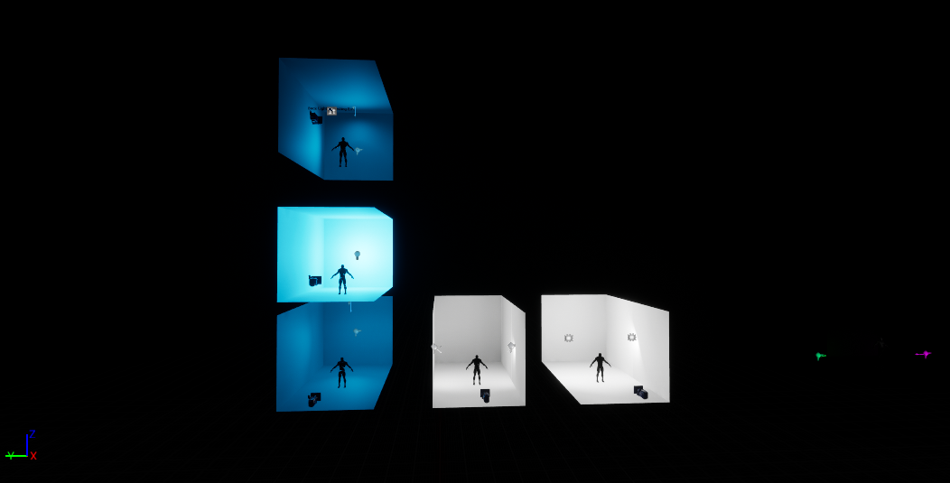
Dark fields
Dark fields allow for creation outline of the objects or highlighting the imperfections that are normally not visible on its surface. It can be used to mark the presence without showing/illuminating the whole object.
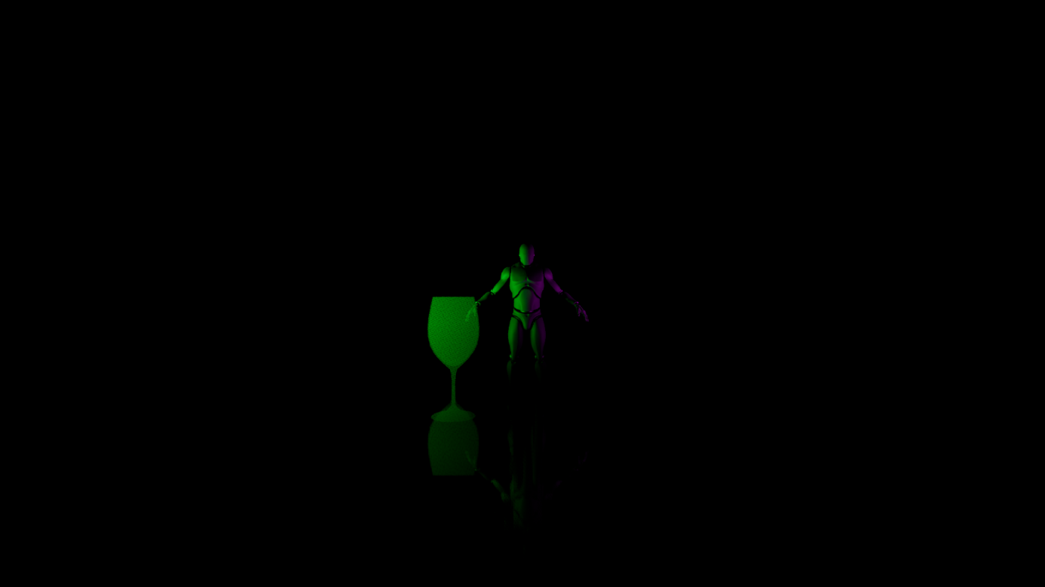
Saturation
Transferring between different environments with different saturation should change the tension of the perceived image. Changing the value to lower should release the tension and increasing the value makes the rise the tension.
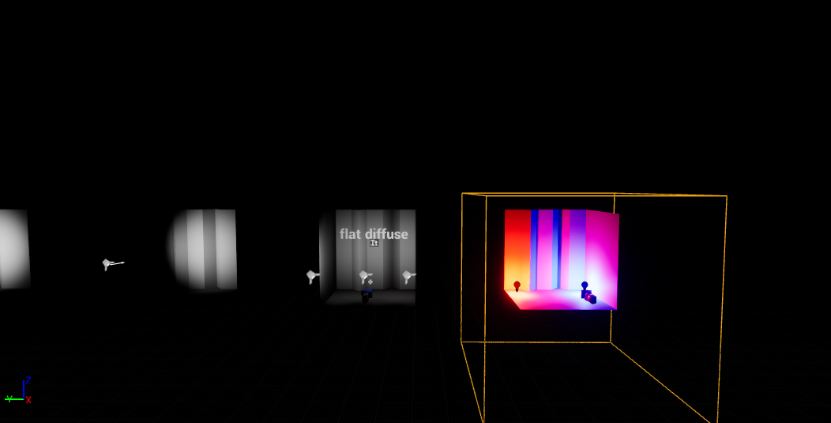
Contrast
Contrast allows for changing how the scene is being perceived. Very high and low values can be used rise the tension and help to build the negative feelings. The values closer to normal allow to lower the tension perceived by the viewer.

Colour temperature
Warm colours of the illumination help to build more friendly environment. The cold colours of lighting are being used to create the environment with more negative feelings.

Expressional Lighting engine
By manipulating the factors and techniques mentioned above, it possible to create system that adjust the factors of the lighting dynamically. That should allow for more immersive effect that will adjust to the players playstyle.

Overstimulation
To ensure the correct result the techniques presented should not be used constantly due to overstimulation. Instead, the viewer should be presented with more normalised version of the illumination. The techniques should be used in the key, specific moments what would allow to unleash their full potential and to keep the viewers tension in optimal state.

Player types
Because different player types might be attracted to different types of the lighting the playtest environments were built with two types of illumination - positive and negative. Before participants participate in playtest sessions, they were asked to discover their player type by filling The Bartle Test of Gamer Psychology. The playtest environment was later picked to match to the test result.

The observed results

The Bartle Test of Gamer Psychology
Before starting playtesting, the project in engine participants were asked to identify their player types. Here are the results of the 11 participants who completed the forms:

The results will be compared with results of other environment, what will allow for analysing results based on the subgroups.
Video - testing showcase

First environment
In the first testing environment participants were tested what type of the illumination attracts them the most. They were presented with single room and two paths leading out of it to the next room and were asked to pick one of them. Each path was presenting different illumination technique. Participant had to make choice in 7 rooms.

First Room
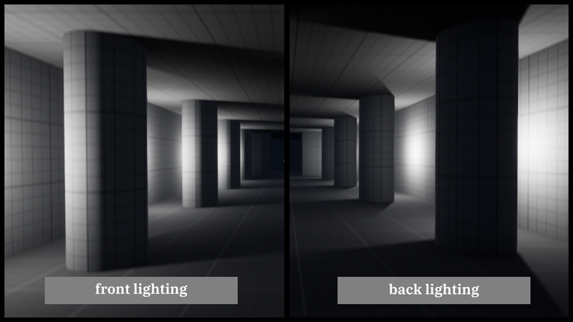
First room was testing players with the lights and shadows. The direction of the shadows in the paths is different what creates different shadow patterns on the surrounding environment. The left environment was associated as positive and right as negative based on the type of the illumination and shows created.
27% of the participants picked the left path and 73% the right path. Most participants while provided feedback that the right environment looked more “interesting”, what encouraged them to pick this path.

Second Room
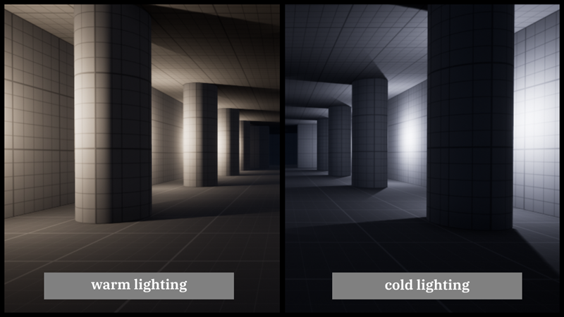
Second room tested the colour temperature. Participants were presented with the warm illumination on the left and cold light colour on the right. 64% of participants picked the left path and 36% the right path. In verbal feedback participants stated the left illumination looks more “safely”.

Third room
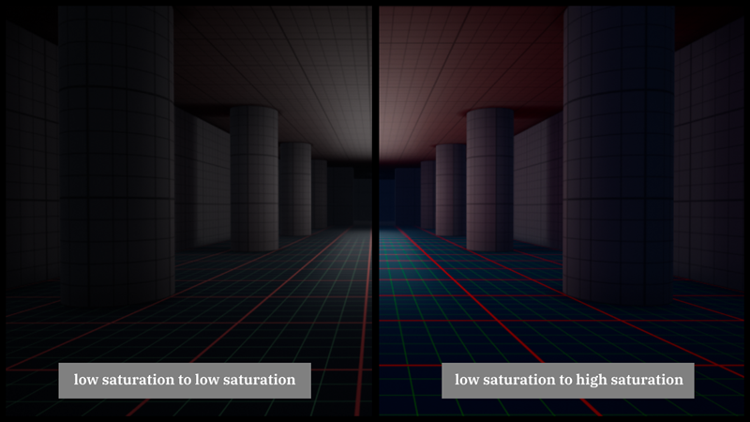
Third room presented participants with the transition from low saturated room to two paths- left with also low saturation and right with higher saturation. To show colour change better the environment was adjusted. Keeping lower saturation (picking left path) was associated with lower tension and therefore positive response, like suggested in analysed materials. Right path used higher saturation what made colours more outstanding and was associated with negative feelings.
The left path was picked by 36% of participants and the right was picked by 64% of participants.

Fourth room
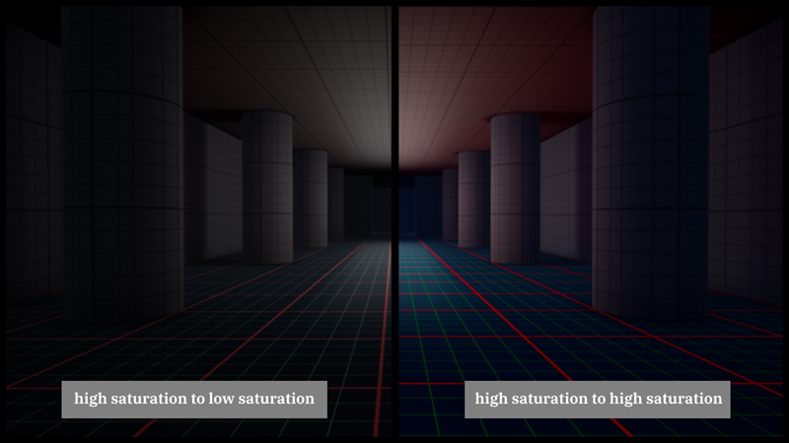
Fourth environment presented participants with opposite approach. Players started with environment with higher saturation, what accordingly to analysed materials should increase the tension. The left path presented participants with lower saturation and right path with higher saturation of colours.
Left path was picked by 36% and right one by 64% of participants.

Fifth room

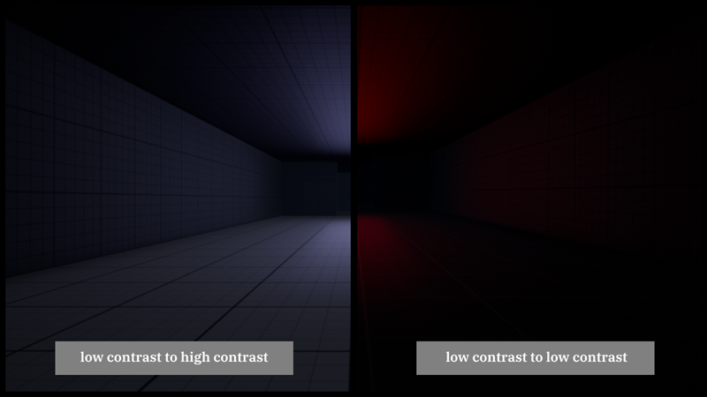Fifth room presented players with transition from contrast room to the room the low and high contrast room. As suggested in analysed materials the light sources were adjusted to support the effect created by post process contrast settings. The left path with lower contrast settings is associated with more natural and pleasant feelings, where the right one was supposed to build the negative responses. Picking the path from low contrast room to low contrast path should maintain the tension on low/neutral level and traveling from low contrast room to the high contrast path should rise the tension.
The left path was picked by 73% and right by 27% of participants.

Sixth room
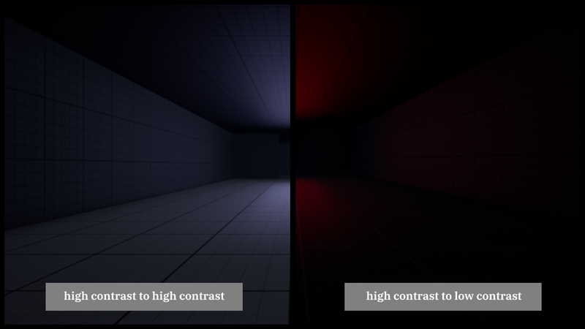
Sixth room show the transition from high contrast room to the left path with low contrast or to the right path with higher contrast. Participants were expected to experience realising the tension by picking the left path or building the tension by picking the right path.
The left path was picked by 73% and right by 27% of participants.

Seventh room
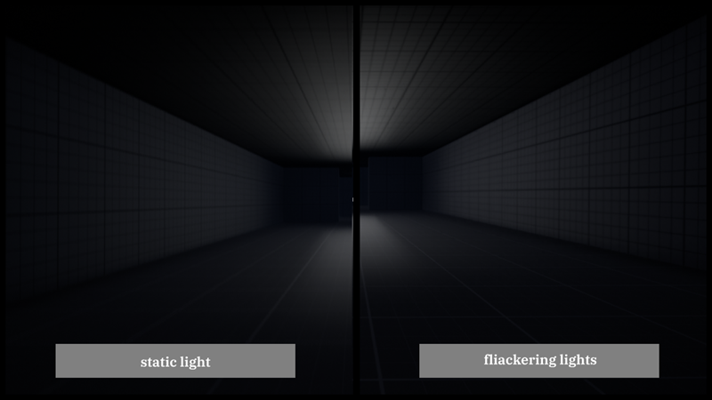
Last room presented participants with the chaos techniques in form of static light in left path and strobe, flickering light on the right path. The static light of the left was associated with stability and therefore a positive response, where right with blinking light created chaos which was associated with negative feelings.
Left path was picked by 45% and right by 55% of participants. Here again participants described the flickering light as scary but more interesting what encouraged them to exploring this path.

All results
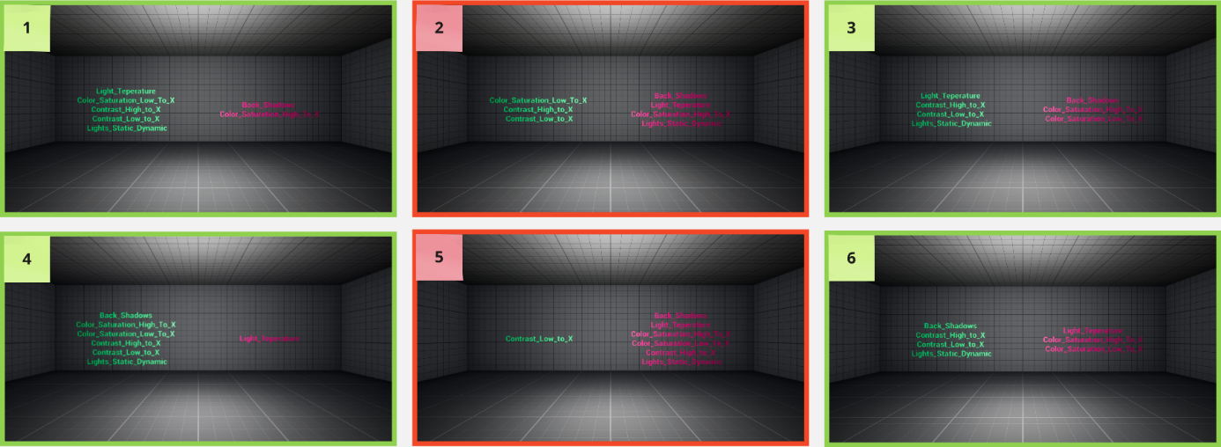
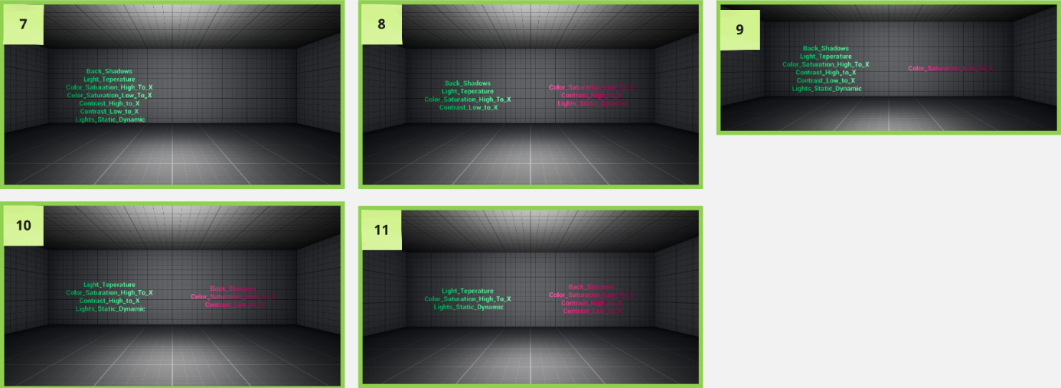

Maze environment
When finished the first environment, participants will be presented with the results, that will show if they are more attracted to the positive illumination that tends to lower the tension or to the negative illumination that tends to rise it. The is presented by the print string statement visible on the screen and by the screenshot obtained by the participant.
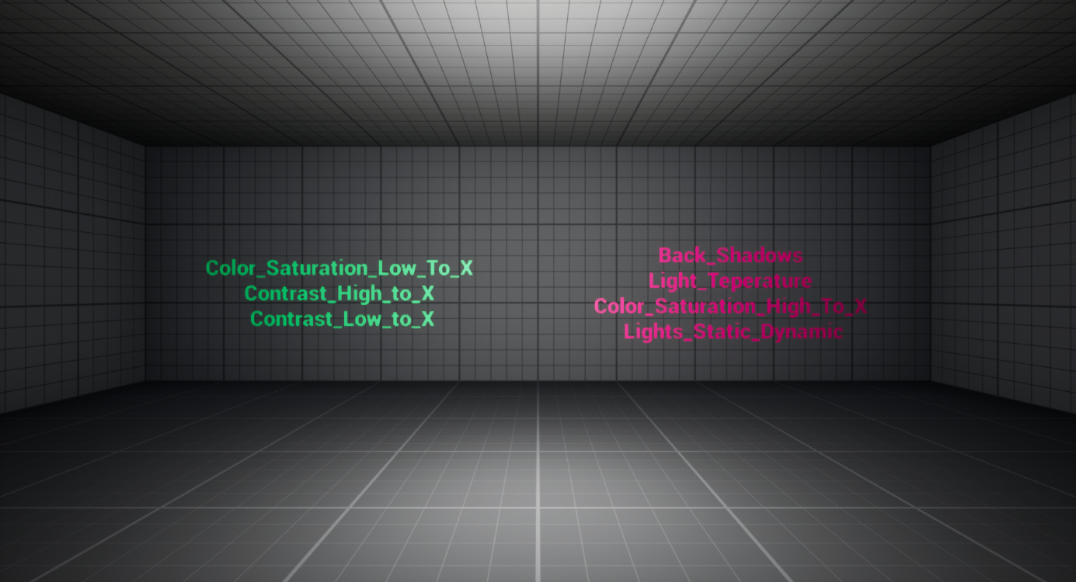
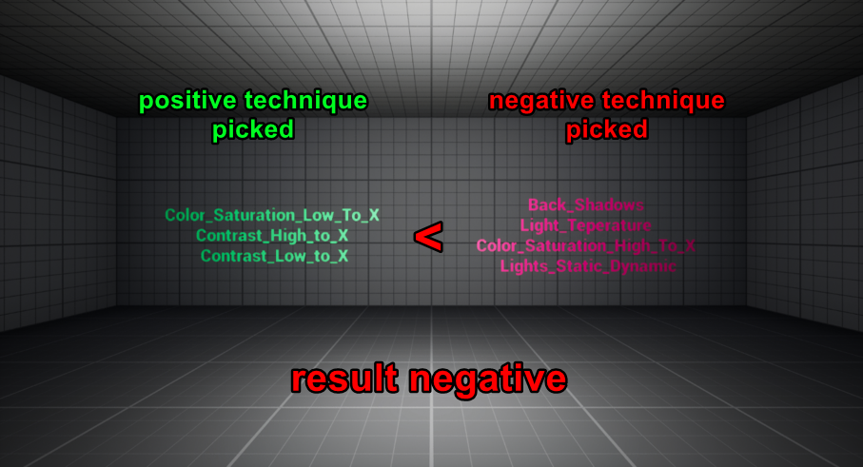
Based on the result, next testing environment is being opened. The second testing environment has form of a maze and exists in two versions – positive and negative. Both worlds have the same structure and maze, but they used different illumination techniques to guide the player.
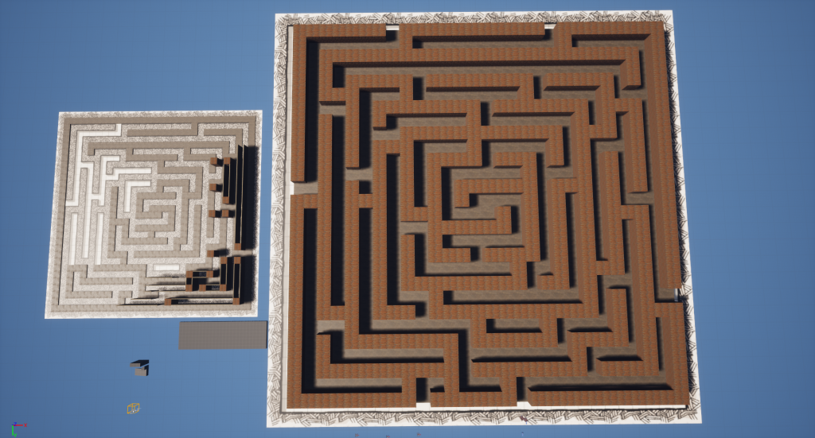
Participants started at the centre of the maze and were presented with two possible paths, each leading to the exit – outside of maze. The time of the completion of the maze was measured to evaluate the effectiveness of the discussed illumination techniques as a form of guidance. The environment was built to use only necessary elements, without props and decorations to avid the factors that might provide false guidance method.
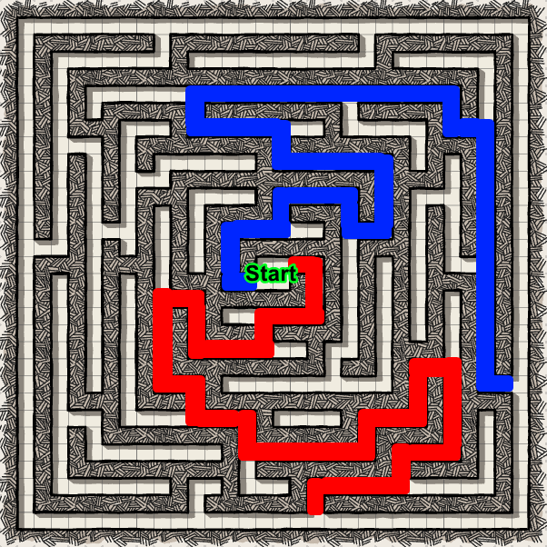
Because the paths are not equally long the best time used as control value is between 1min 20s – 1min 30s.
Here are the results of all participants:
1 | 1min 55s
2 | 2min 1s
3 | 7min
4 | 2min 26s
5 | 1min 55s
6 | 1min 44s
7 | 3min 18s
8 | 2min 30s
9 | 1min 45s
10 | 2min 58s
11 | 1min 57s

Additionally, the results can be split based on the illumination that participants preferred.
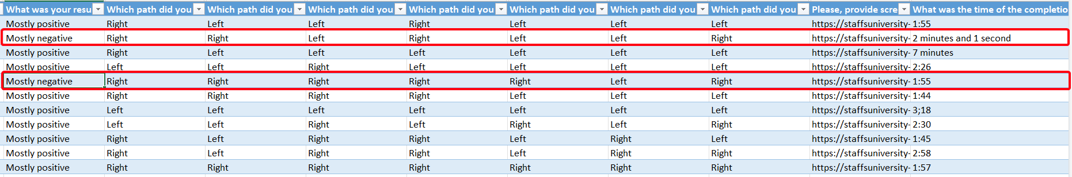

Positive environment
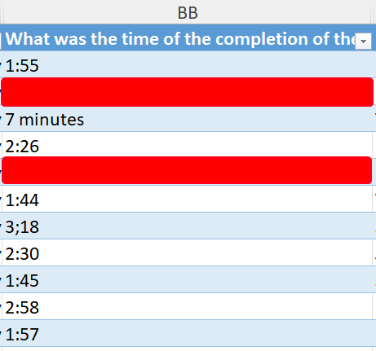
As visible on the table above, none of the participants achieved the time as on control sample. Four participants however achieved the time below 2 min, so close to the time needed for picking every path correctly.
Out of all participants with positive result only one picked all positive techniques out of presented in first environment. The rest participants picked wrong option for:
- Strobe Lights – 1 participant
- Transition from low to high contrast – 2 participants
- Transition from high to high contrast – 2 participants
- Cold colour lights – 2 participants
- Transition from high to high saturated environment - 3 participants
- Back lighting – 4 participants
- Transition from low to high saturated environment – 6 participants
Presented results allow to identify the techniques that were hard to recognise or wrongly recognised as positive by players with positive results. That suggest that some techniques are easier to identify as positive or negative than other, with back lighting and saturation changes being most difficult.

Negative environment
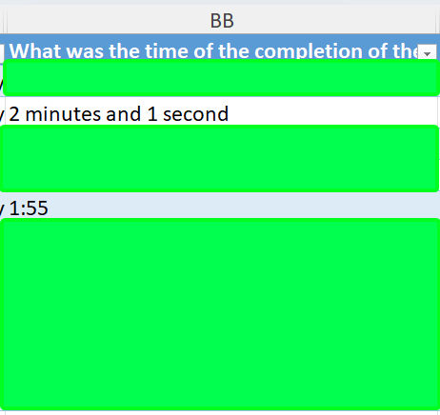
Players who participated in negative environment also did not achieve the exact time (between 1min20s and 1min30s) but were close and completed the playtest under 2 min.
Participants who were more attracted to negative environment wrongly identified:
- Transition from low to low saturated environment – 1 participant
- Transition from high to low contrast – 1 participant
- Transition from low to low contrast – 2 participants
These participants identified most of the techniques correctly however transferring between environment with different contrast did not seem to work effectively enough.

Participant feedback
When asked about the methods of guidance participants referred to the:
- Dark and illuminated spots
- Light colours
- Flickering lights
The responses show that participants remembered the more visible techniques that were created with the light sources itself. The techniques that were passed on post process actor like changes in saturation and contrast seem to be not noticeable enough.
Participants were asked if they experienced any confusion during second testing environment.
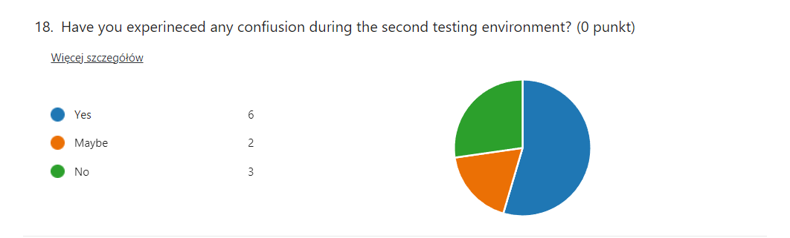
Over half of them answered “yes” shows that not all techniques were effective or not all techniques are always identified as positive or negative.
When asked about the confusion and what affected it participants answered:
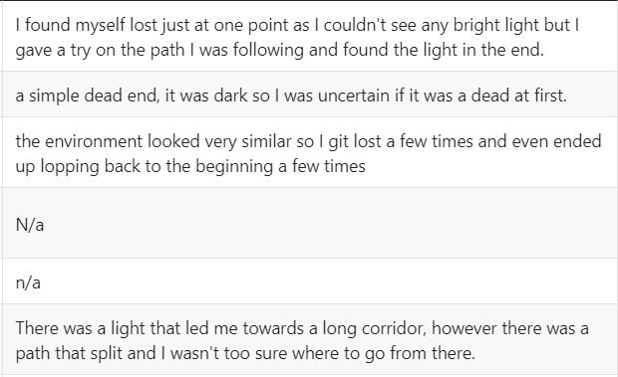
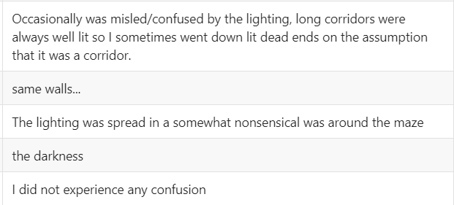
The similar looking environment was a conscious action that was supposed to eliminate other possible guidance methods.
Some of the light placement did not allow for identifying if the path was there from distance. This technique was used in longer corridors to check if player will trust the picked guidance method and follow the path to find passage at the end or will rather be looking for more promising path.
When asked about feelings and emotions experienced participants answered:
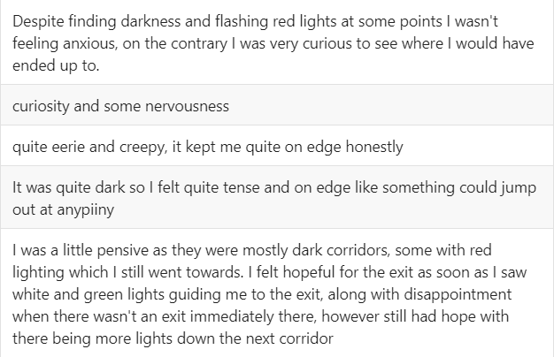
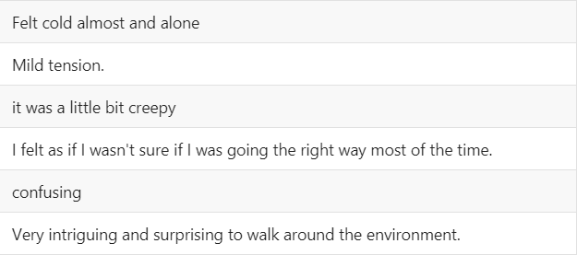
Building emotional responses was successful. Participants were able to identify the spots where they could feel fear or higher tensions and spots that allowed to release it. Some of the participants also mentioned feeling curious when presented with some techniques. When asked about them they answered:
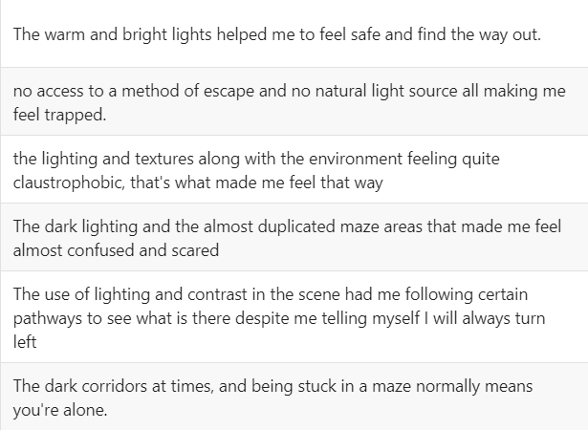
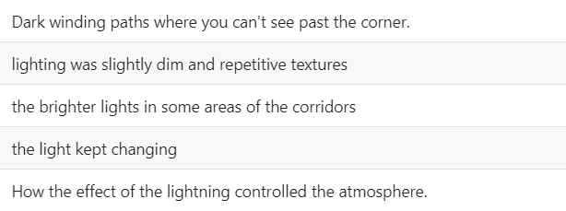

The results
Based on the collected the conclusion can be made. The illumination methods are capable of player guidance however they have limitations.
Not all players are being attracted by the same illumination techniques so its hard to create experience that will be uniform to all players. The techniques that are visible locally - those build with light sources, seam to be more noticeable and are easier to identify rather than techniques that are done via post process like saturation or contrast.
Because of that the lighting as a form of guidance should not be used as the primary method of guidance. It can however be used as supporting method. Additionally, to create more noticeable effect, methods used for guidance should be limited to those using light sources, not post process. Method that are using postprocess like saturation and contrast or not so noticeable in matter of guidance and they affect usually all objects present on the screen. The post process methods are much more effective for build emotional responses.
Additionally, the techniques can be potentially improved or used more effectively to prevent participants form looking for methods for quick solving the maze when they got lost.

Subgroup results
While researching the player types I assumed that Killers and Explorers will be more attracted to negative illumination because it can be associated with danger, tension or something more interesting for the player.

Killer
The participants who associate with the killer type scored positive result on first testing environment. That means they were attracted to the techniques associated with lower tension.

Explorer
Almost all participants associated with explorer archetype scored positive result, with one exception. Their time result from second testing environment was tended to be longer than other archetypes.

Achiever
Two participants associated with the achiever type. Both completed maze in small time, where one of the achievers finished it as the fastest among all participants. Both achievers were attracted by illumination techniques that release the tension.

Socialiser
Two participants who associated with socialiser archetype finished the maze in average time but over the control time. What’s surprising one of them was attracted by the techniques that increased the tension.
By analysing the result, the conclusion can be made that different player types might be attracted by different mechanics however it doesn’t seem to consider illumination. Most of the participants followed the low-tension path and those who picked the path with higher tension justified their decision by stating that “path looked more interesting”. Based on that player type has no influence or almost no noticeable influence on the illumination technique that attracts the player.

Discussing the results
To summarize, I consider this project a success. It allowed for identifying the potential techniques that can be used in game industry in both level design and building emotional responses. However, the number of the participants who submitted they response is not big. The bigger number of participants would allow for more general result, especially regarding the player type data.
The illumination techniques used in movie production, theatre and photography can be reaccreted in engine with some limitations. They can be used successfully for building emotional responses, tension manipulation and chaos creation. They can also be used as a form of the player guidance what might be useful in level design, however they should not be used as primary method. Different players seem to be attracted by different method what might make using lights as a single guidance method not particularly efficient. Additionally, techniques that are being created with light sources are being more noticeable than techniques that are using post process. That makes them better solution if one wants to use illumination as form of guidance.
Furthermore, the research only discus and test the techniques within simple environment. It would be valuable to extend it and check how the presence of the other objects influences the effectiveness

Additional work
To present how the techniques can be used in game, small scene was created to present some of the researched methods.
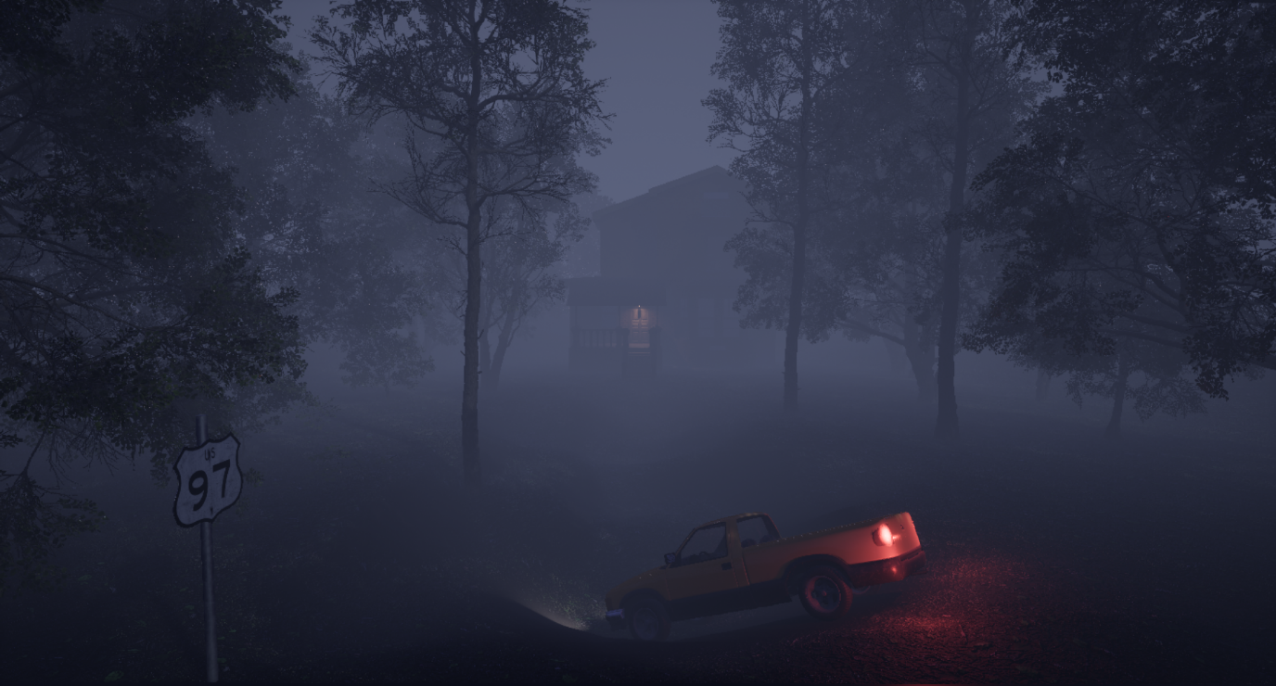
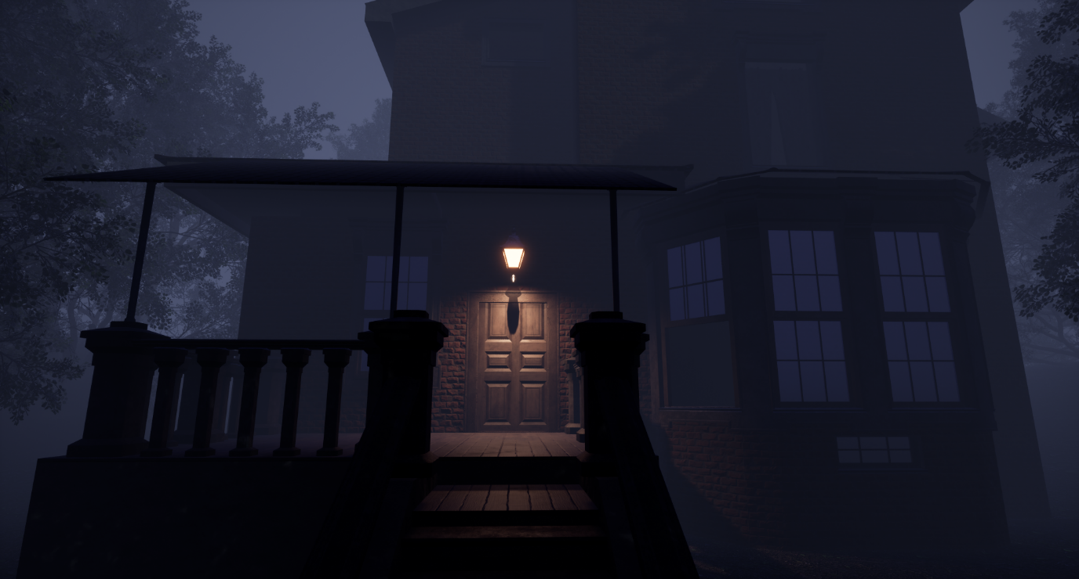
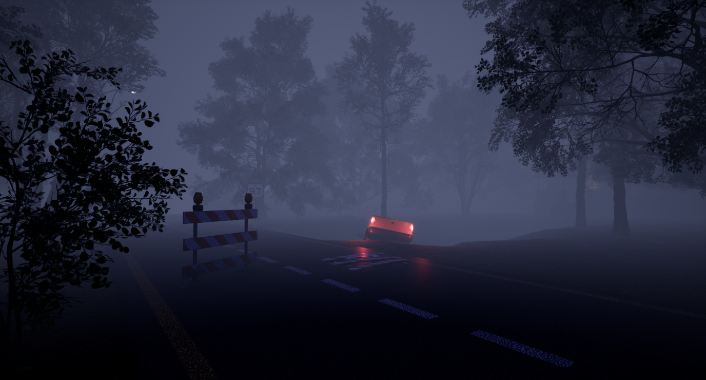
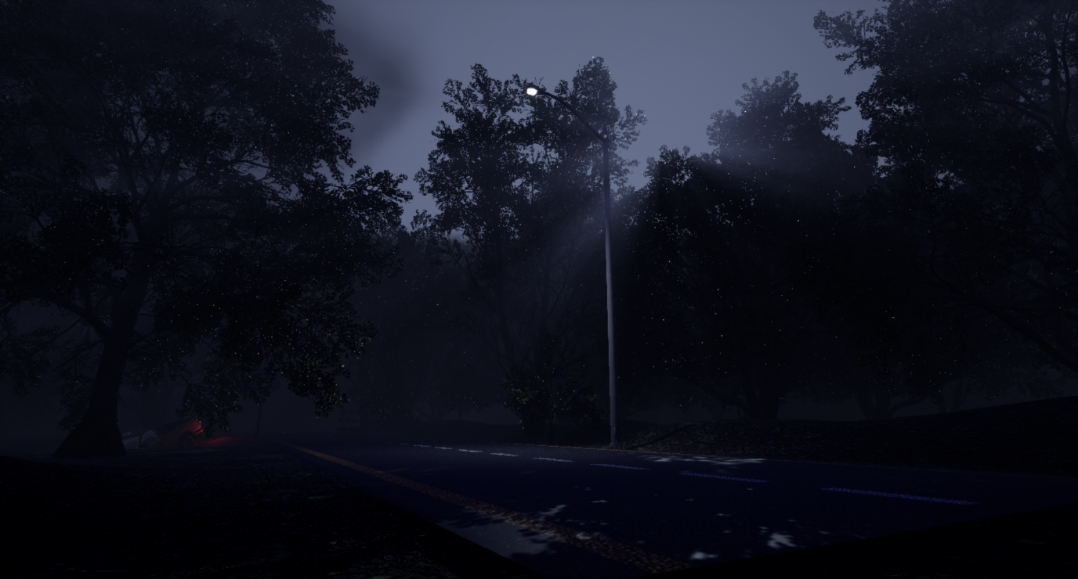
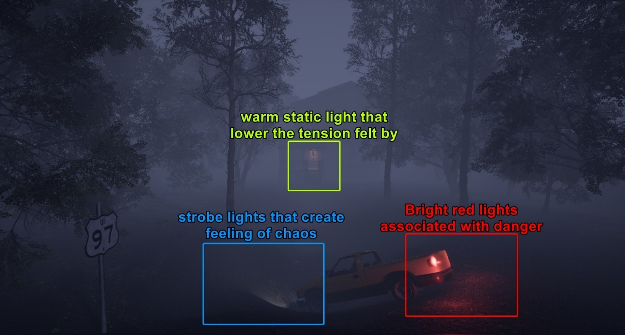

References
Almoqati, T. (n.d.). How can you use lighting to create chaos or confusion in a film? - Strobe lighting. Retrieved from LinkedIn: https://www.linkedin.com/advice/0/how-can-you-use-lighting-create-chaos-confusion-lv2of
Bayer, S. (Director). (2010). A Nightmare on Elm Street [Motion Picture].
Films, C. (2023, 11 06). The Art of Film Lighting: Creating Atmosphere and Mood on Screen. Retrieved from Medium: https://medium.com/@cleverstreet.films/the-art-of-film-lighting-creating-atmosphere-and-mood-on-screen-5a57042933b7#:~:text=Soft%2C%20dim%20lights%20can%20create,%2C%20danger%2C%20or%20stark%20reality
Haus, T. (2020, August 10). Theatre Haus. Retrieved from How to Set the Mood: A Complete Guide to Theatre Lighting: https://www.theatrehaus.com/2020/08/how-to-set-the-mood-a-complete-guide-to-theatre-lighting/
Illumination Techniques. (n.d.). Retrieved from Machine Vision Direct: https://machinevisiondirect.com/pages/illumination-techniques
Jackson, M. (2018, Oct 25). Retrieved from Mental Floss: https://www.mentalfloss.com/article/503550/14-unforgettable-facts-about-%E2%80%98suspiria%E2%80%99
Kleinloog, R. (n.d.). How can you use lighting to create chaos or confusion in a film? - low-key lighting.
Magazine, I. 1., & Video Gear. (2015, 09 19). Film Lighting Tutorial: Double Diffusion for Soft Beauty Lighting. Retrieved from Iso1200.com: https://www.iso1200.com/2015/09/film-lighting-tutorial-double-diffusion.html
Magy Seif El-Nasr, S. N. (2007). Dynamic Lighting for Tension in Games. Game Studies .
Mueller, M. (2012, Mar). Two more Dark Field Lighting images + shot of my setup. Ottawa, Canada. Retrieved from https://www.cambridgeincolour.com/forums/thread68105.htm
Peach, M. (n.d.). How can you use lighting to create chaos or confusion in a film? Retrieved from LinkedIn: https://www.linkedin.com/advice/0/how-can-you-use-lighting-create-chaos-confusion-lv2of
Peach, M. (n.d.). How can you use lighting to create chaos or confusion in a film? - Colorful lighting. Retrieved from LinkedIn: https://www.linkedin.com/advice/0/how-can-you-use-lighting-create-chaos-confusion-lv2of
Sellin, C. (2013, 04 14). 400-Level: Film Theory & Criticism. Retrieved from Mahara: http://mahara.cs.lewisu.edu/view/view.php?id=554

