Gameplay System Design Task 3: Phasmophobia novel system

Filip Lichonczak - l026819k

Table of Contents
High Level Summary 2
System Essence Statement 2
Chosen Game Analysis 2
System Analysis of Chosen Game 3
Problem Statement 5
How the System Addresses Problem 5
Core System Concepts 6
Ways of evidence identifying 6
Expected Player Experience 9
Game Research 9
Chosen Game Research and Analysis 9
Design Considerations with Chosen Game 10
Similar Games Analysis 10
Similar Systems Analysis 10
Dead by Daylight 10
Oxygen Not Included 10
Academic Research 10
Summary of How Research Guides Design 10
Iterative Documentation 10
Design Outputs Iteration 1 10
Iteration 1 Evaluation 10
Rationale for Changes Iteration 1 10
Design Outputs Iteration 2 10
Iteration 2 Evaluation 10
Rationale for Changes Iteration 2 10
Prototyping 10
Rationale for Prototyping 10
Documentation of Prototype 10
Evidence of Prototype 10
Evaluation / Lessons Learned from Prototype 10

High Level Summary

System Essence Statement

Chosen Game Analysis
Phasmophobia is a 4-player online co-op psychological horror. Paranormal activity is on the rise and it’s up to the players to use all the ghost-hunting equipment at their disposal in order to gather as much evidence as they can. During the investigation, players must face scary events and avoid deadly ghost hunts.
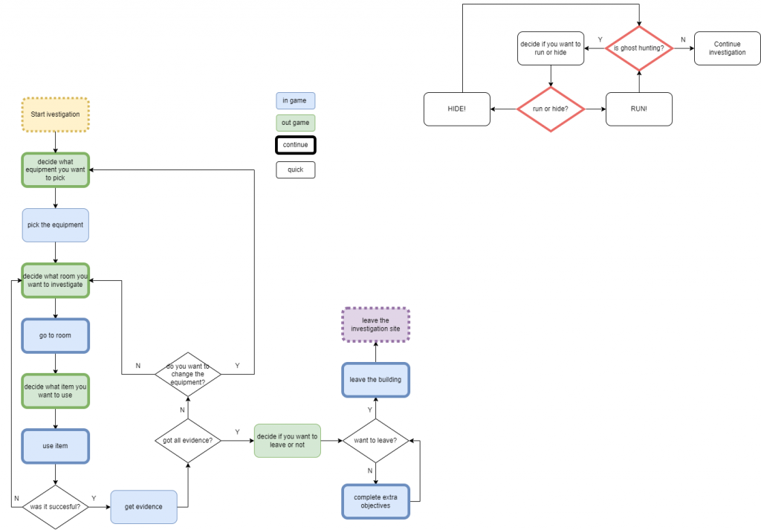
Current gameplays offer progression in form of the gameplay difficulty, daily and weekly challenges, trophies and item upgrades. None of these systems however affect the player knowledge.
During the game, player learn to identify the ghosts, learn how to use the items, their properties and ghost effects. Some of the information remain “hidden” or unclear what sometimes cause gameplay to be confusing and frustrating. The solve the problem I plan to include the system that will allow to unlock those pieces of the information and add them to the journal.

System Analysis of Chosen Game
Progression
Current progression system offers levelling up player rank. As players level up, they unlock new equipment. Once they reach level 17, all items are unlocked, and they start to unlock the upgrades to the existing items.
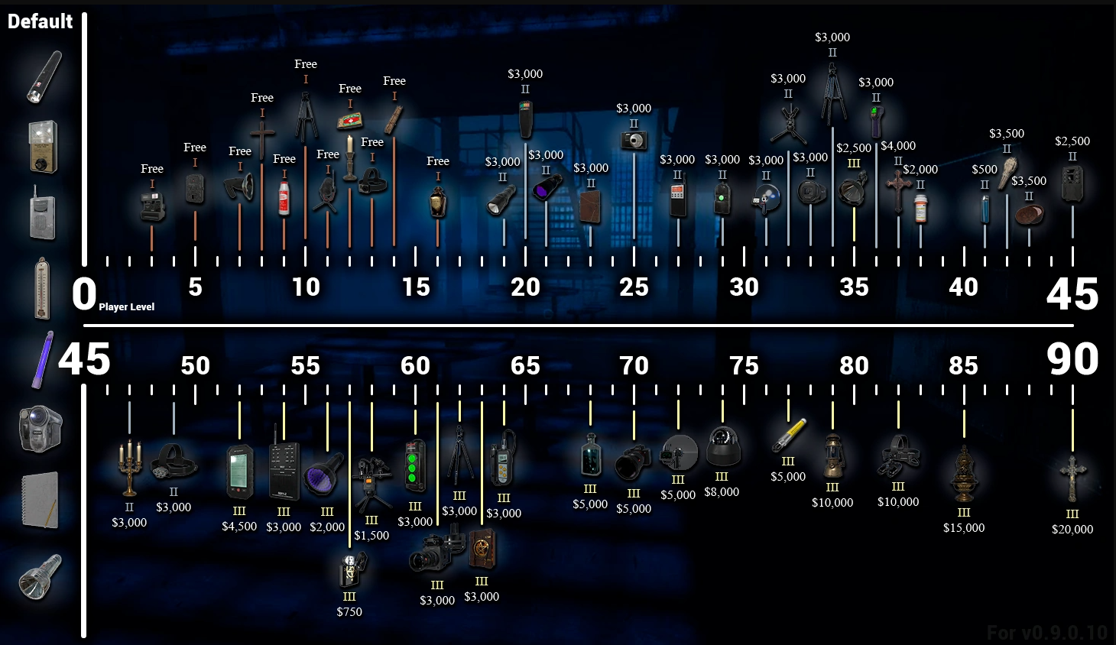
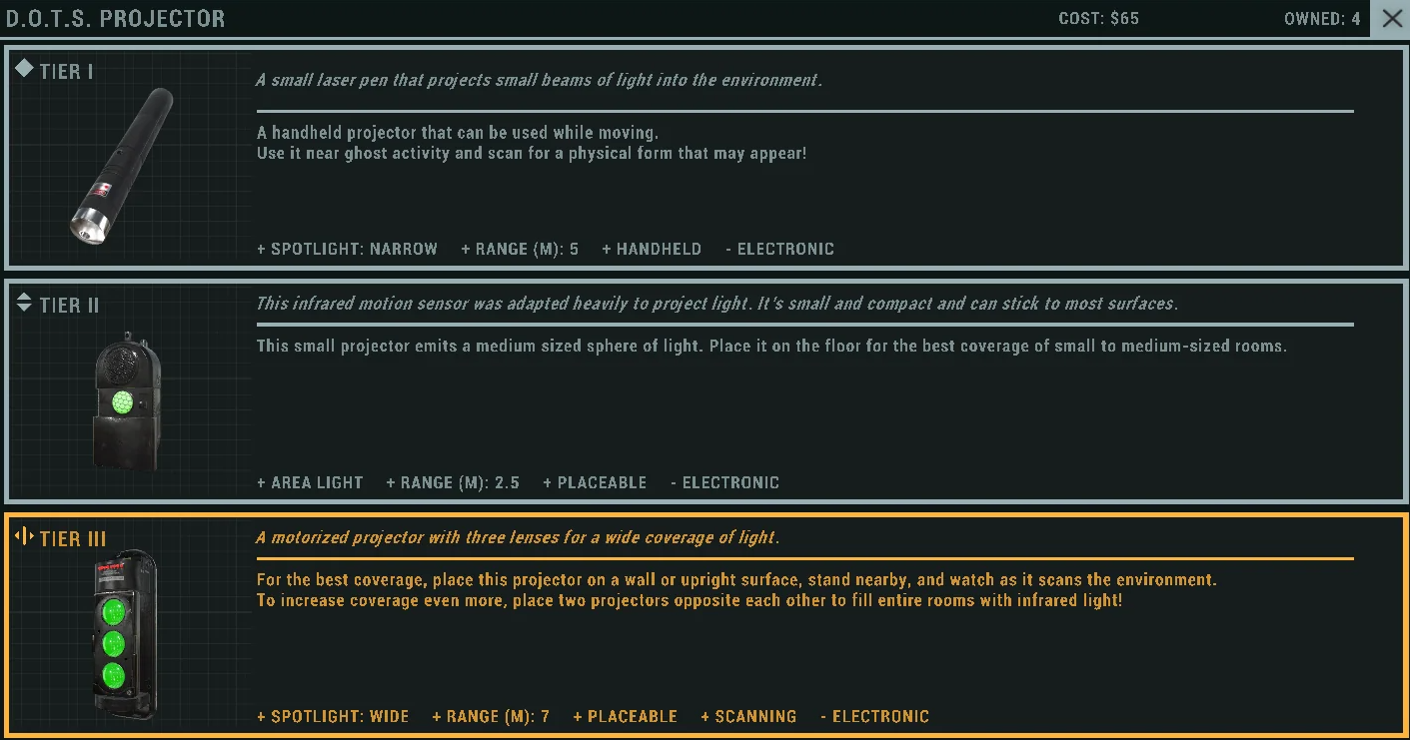
Player starts the game at level 1 without the experience and can reach level 999 by collecting experience points. Player can obtain the experience by finishing the contracts. After reaching the level 100 player unlock option to prestige they account. Prestige action remove the level and equipment in exchange for the new Badge and Title for ID Card.
Examples of couple Id Cards:
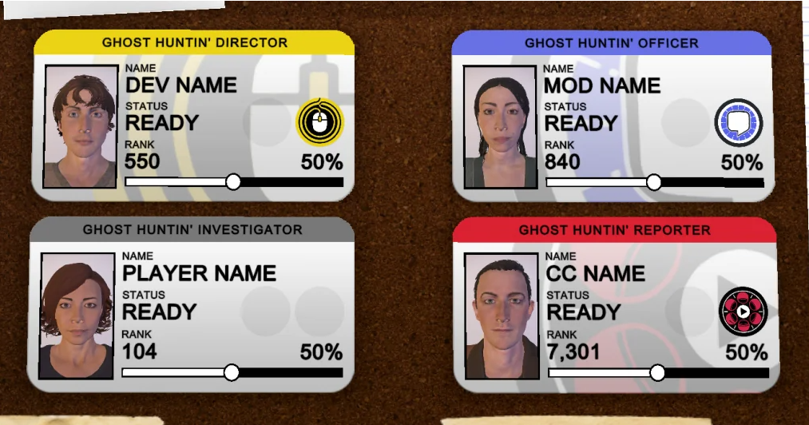
Id Cards show the Name of the player, their level, the badge and chosen character. Except the default ID there are 20 prestige Id cards and badges, so it requires reaching 100 level 20 times to unlock all of them.
There are also additional ID cards and budges that can be unlocked during the event, by being content creator or contributing to the development of the game.

Ghost Evidence
During the investigation players use items to retrieve evidence that will allow them to identify the ghosts. Players are not required to find evidence; they are able to mark them randomly and guess the ghost type. Each ghost has 3 pieces of evidence. Every ghost however has its own unique behaviour and can by identify by it. Additionally, there are ghost who are harder to track, can change their behaviour or place / room of the investigation.
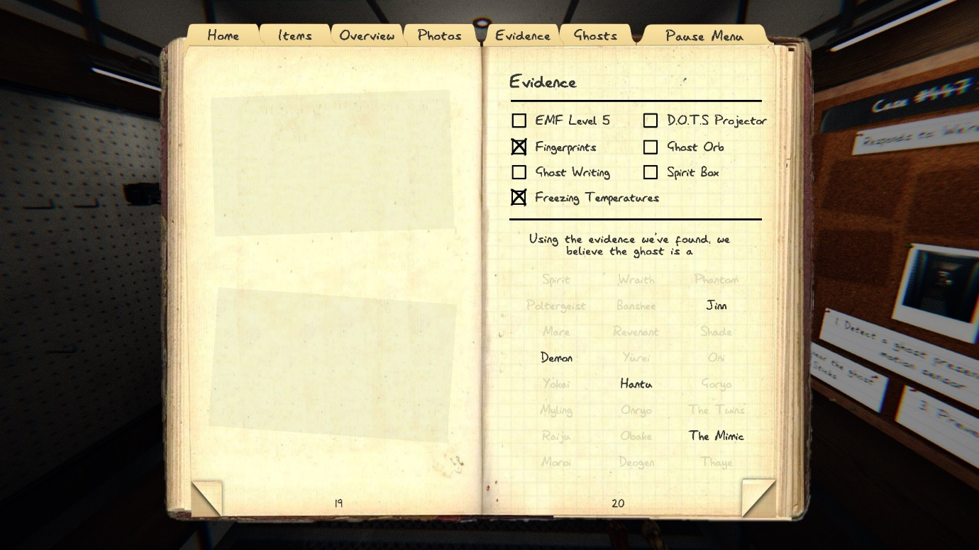
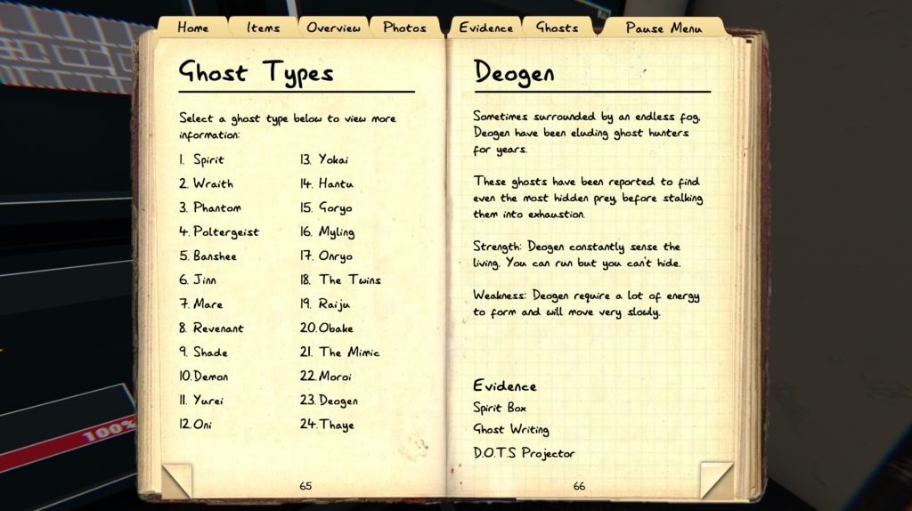

Problem Statement
Each ghost has their own page in the journal that describe the evidence needed to identify the ghost, its strengths and weaknesses and behaviour. The description however seems to be incomplete or very general what might confuse the players. Moreover, the game only allow player to upgrade the equipment, and rank but not the knowledge what creates the gap in the immersion process.

How the System Addresses Problem
The progression in the original game is limited to the player rank and item improvements. Except the equipment and rank there is no progression for the player or anything that would build/improve the feeling of immersion into the game world.

Current progression system allow player to unlock new items and in later upgrade them.
My idea for the system improvement is toad system that will let player to gain knowledge. Player will have possibility to unlock additional information about the ghost what will result with better understanding the game, player immersion and deeper feel of player progression.

Core System Concepts
The key idea is to add optional objective to the game. Player will have possibility to search the map to find the body of the fallen investigator. Players will be able to identify the evidence on the body to retrieve piece of knowledge that will be added to journal if player escape. The process will be similar to the identifying ghost type system.

Ways of evidence identifying
For the purpose of the assessment, I decided to use items that are already existing in the game. Player will be able to use them to gather two pieces of the evidence that will result with piece of information.
Evidence:
Marks – examinate the body and look for unnatural marks
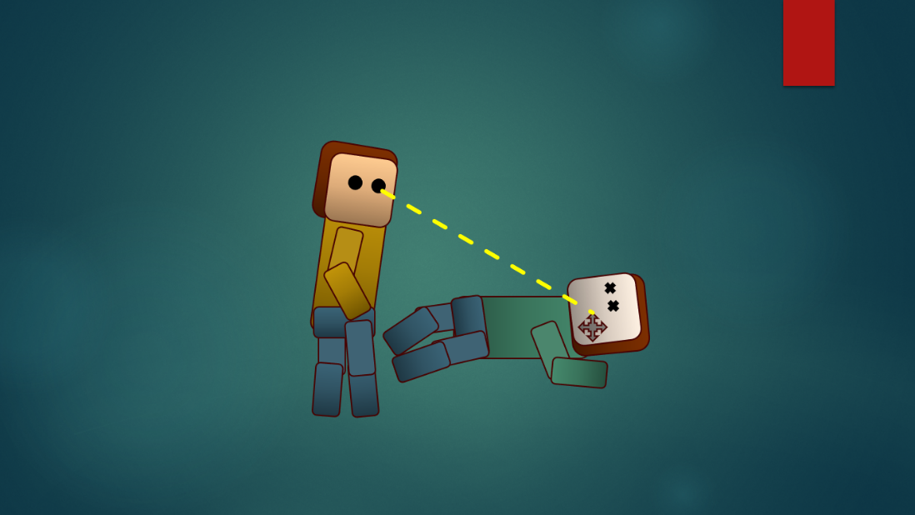
High temperature – measure the temperature of the corpses (thermometer)
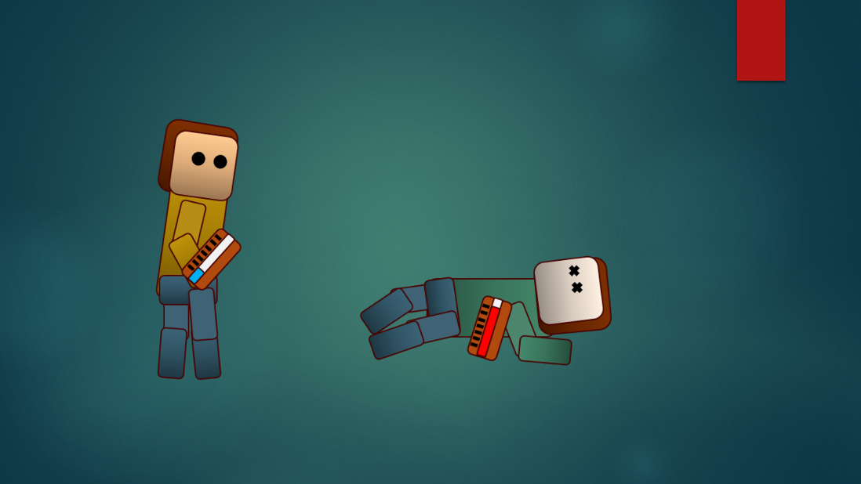
Blue flame – use the fire source to check the colour of the flame in the presence of the body (matchsticks, lighter, candle)
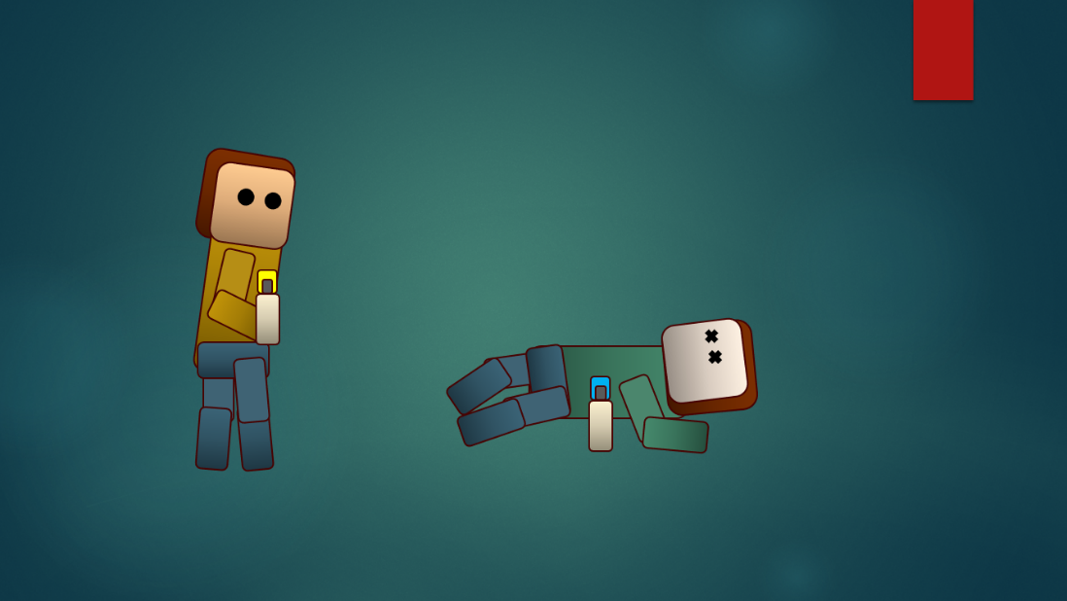
Changing location – use cameras to check on the body location. Only if no investigators are currently in the location body might crawl to different location and leave the scratch marks on the floor
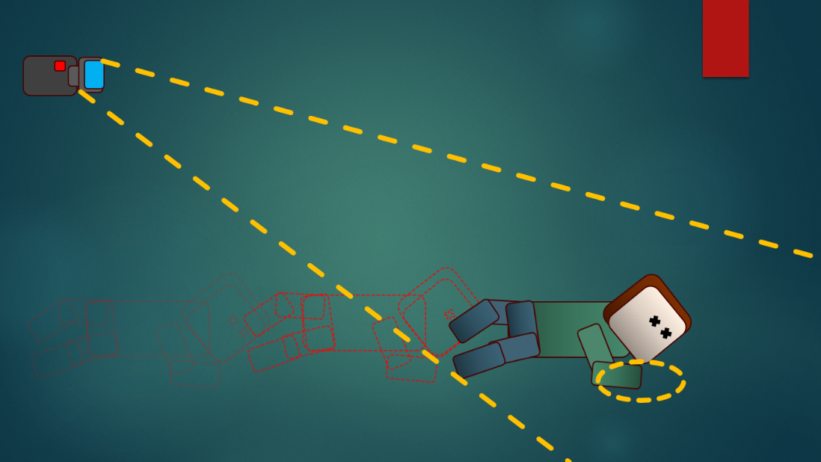
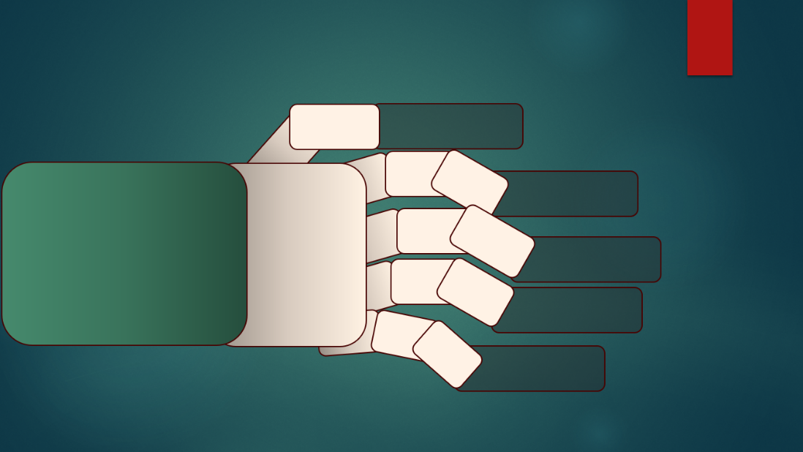
Automatic writing – use writing book in the presence of the body to have a chance of gaining evidence (ghost writing book)
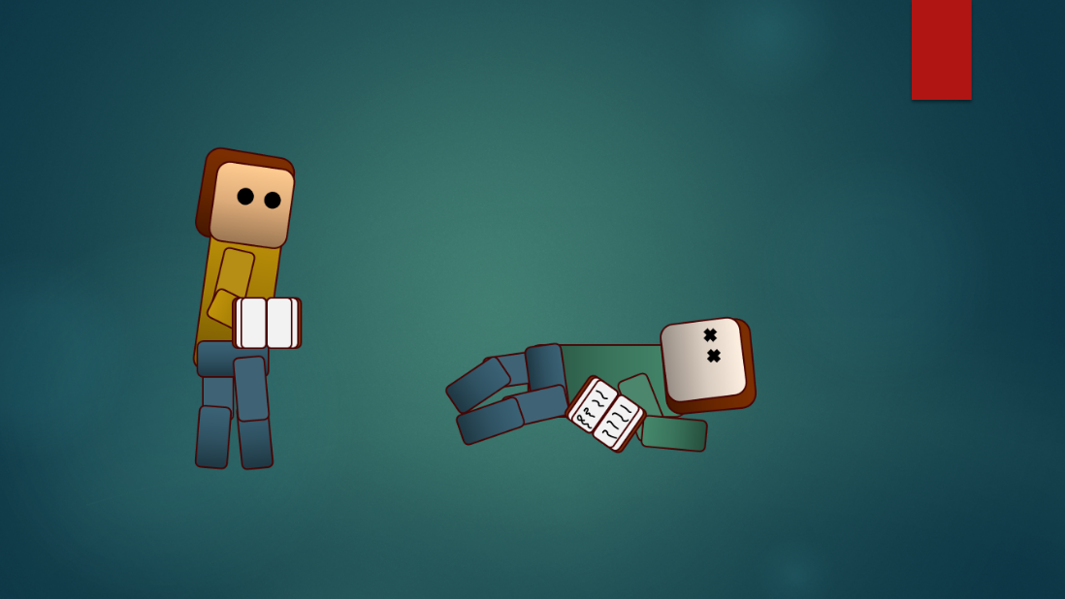
Parabolic microphone – use microphone to check for the sound evidence. The positive result will be scream (parabolic microphone)
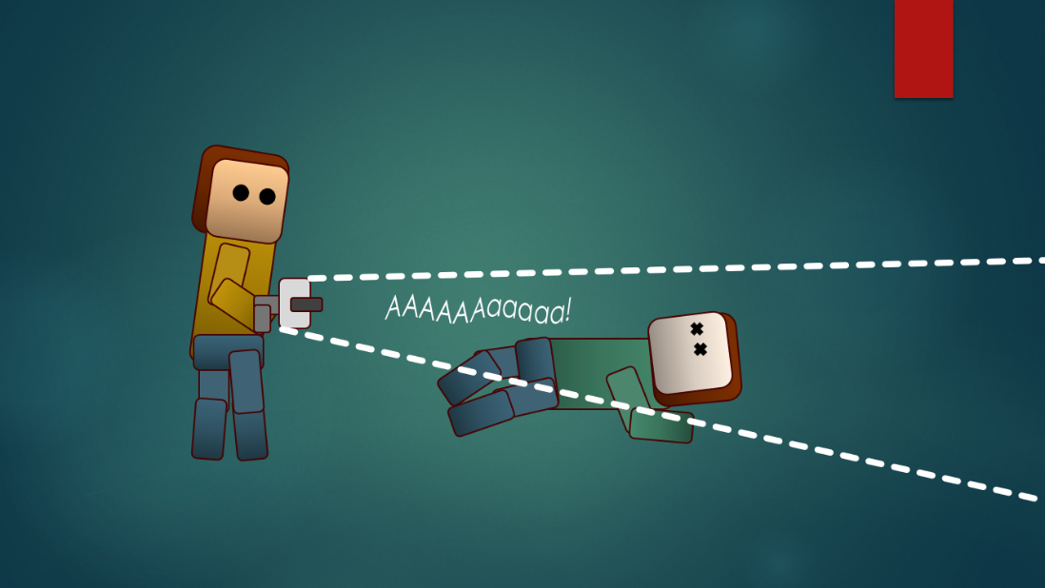

Expected Player Experience
After unlocking all basic items (reaching 17 level) player will have opportunity to find additional information if they play on intermediate or higher difficulty.
I expect to reduce the feeling of boredom and repetitiveness of players who play the game for longer time. Players should experience the feeling of having the chance of improving not only the equipment but also knowledge that will help them to survive in higher difficulties. Gaining the knowledge about the game world should also help with the player immersion process.

Game Research

Chosen Game Research and Analysis
For the game research I decided to crate the MDA diagrams to help me understand what mechanics are in game, what actions can be performed and what game feel they create as a result.
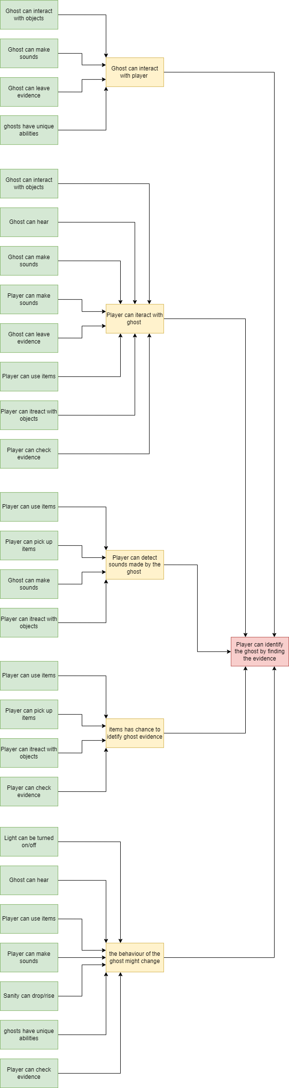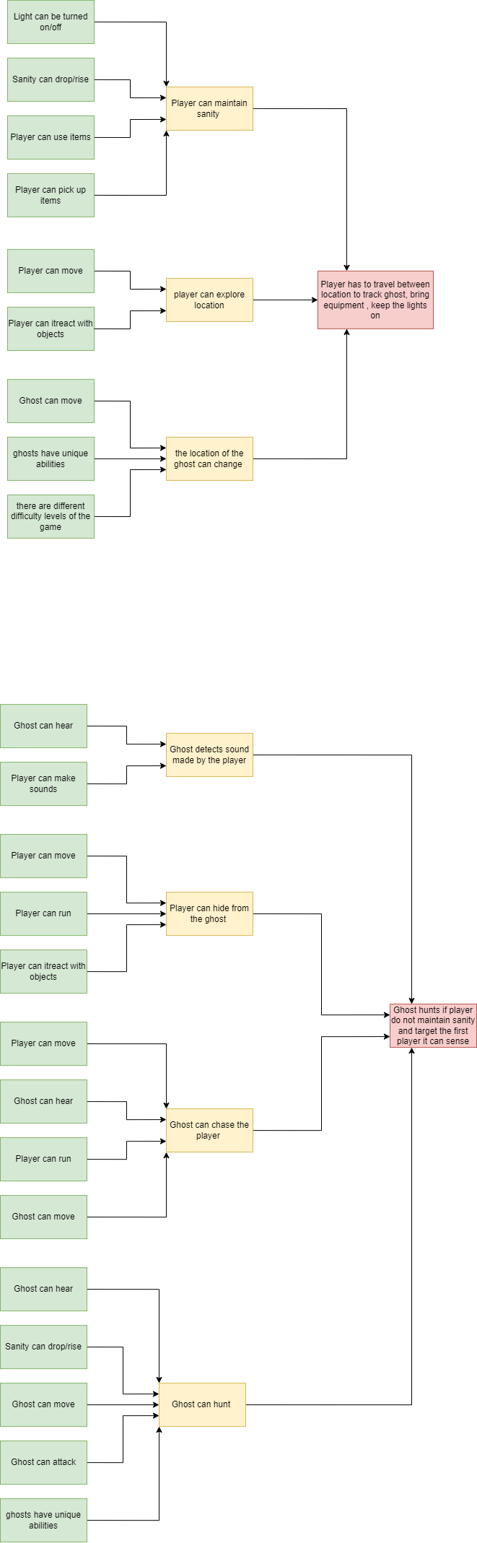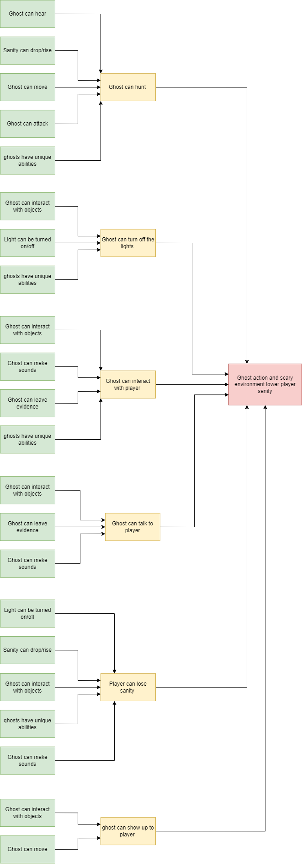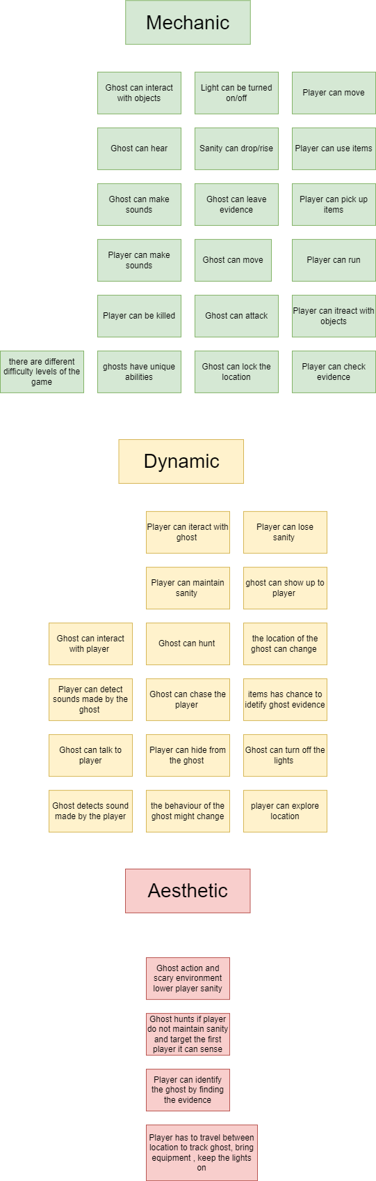

Design Considerations with Chosen Game

Similar Games Analysis

Similar Systems Analysis

Dead by Daylight
Dead by Daylight is a multiplayer (4vs1) horror game where one player takes on the role of the savage Killer, and the other four players play as Survivors, trying to escape the Killer and avoid being caught and killed.

In dead by daylight player beside “standard” progression of the survivor/killer player can find The Collection. It is strictly connected with The Tome and current battlepas. Player can complete the tasks from the current tome to unlcok the notes that unlock the piece of the story in The Collection tab.

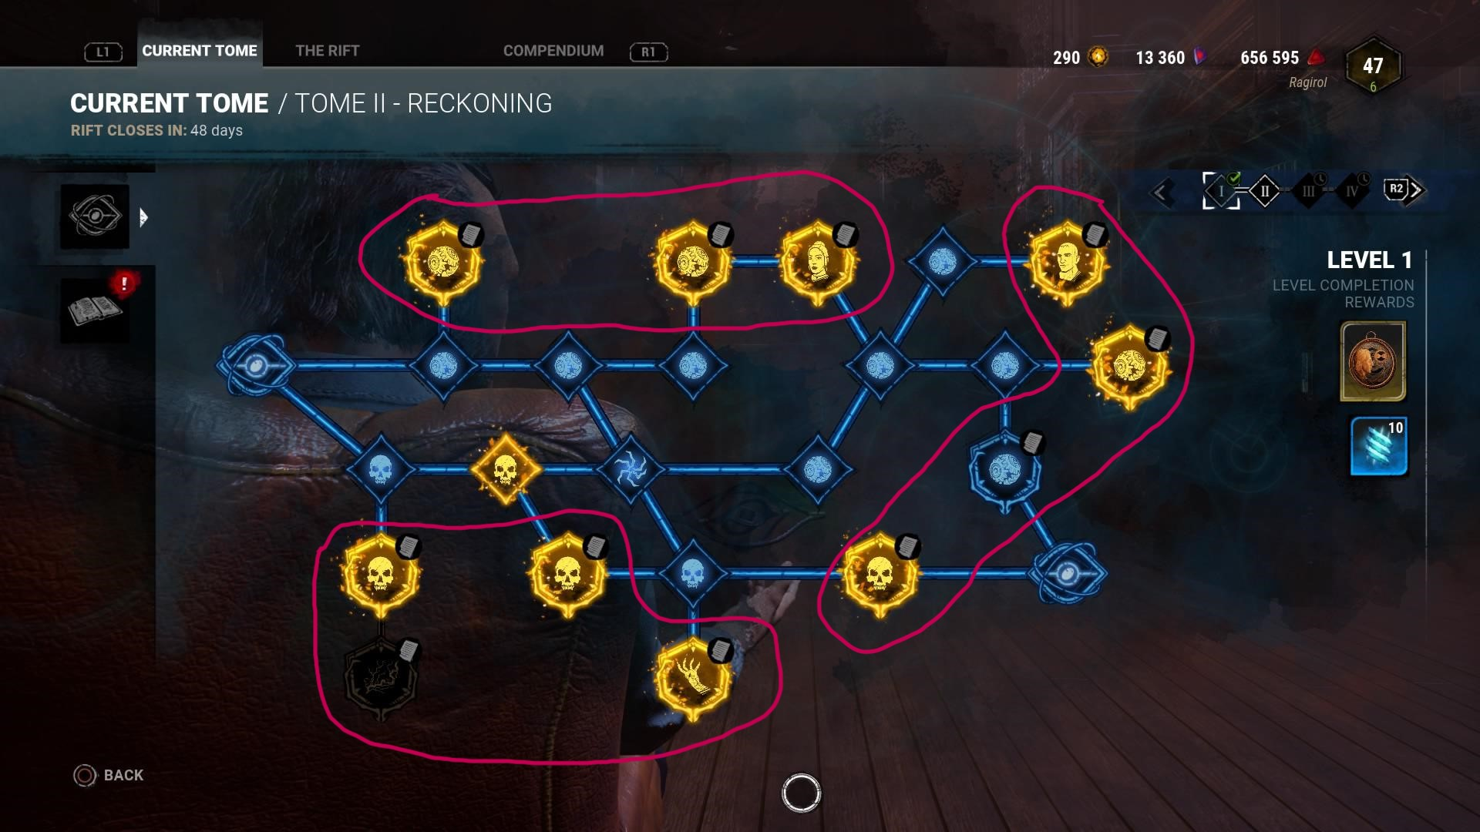

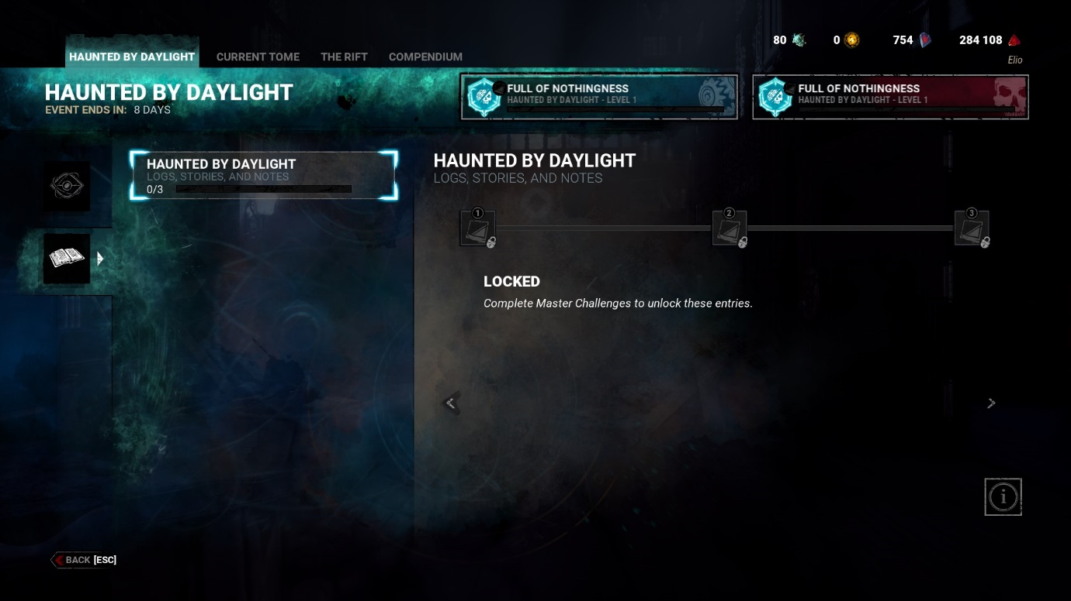
That is great example of leting player discover the story of the gameworld and characters without affecting the gameplay itself.

Oxygen Not Included
Oxygen Not Included is a space-colony simulation game. Deep inside an alien space rock your industrious crew will need to master science, overcome strange new lifeforms, and harness incredible space tech to survive, and possibly, thrive.
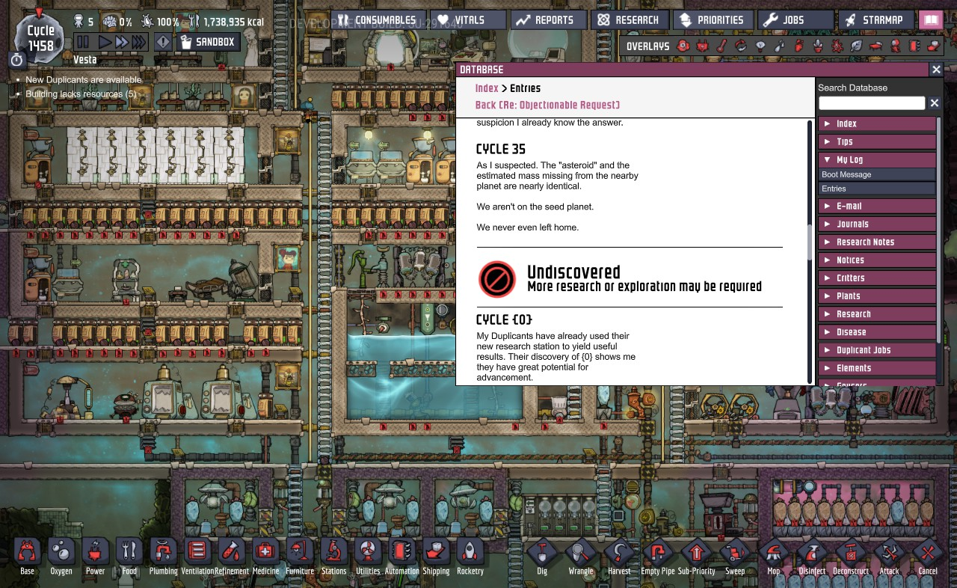
During the game player can find object that can be inspected. As a result, player receives data bank that can be used for crafting and Data Entry. In entries player can find stories of previous duplicants that lived on our asteroid before. It is great example of providing story and additional information in a way that does not affect the gameplay but allow player to discover the story if they want to.

Academic Research

Summary of How Research Guides Design

Iterative Documentation

Design Outputs Iteration 1
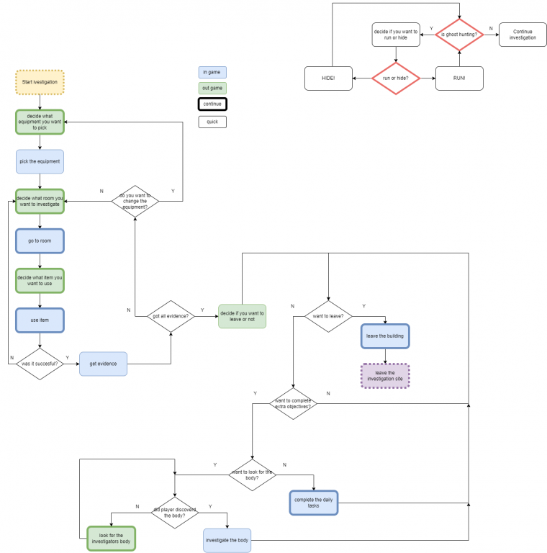
The diagram represents the core loop of the game that includes the changed system. At the late stage where the game usually end player is presented with the choice to continue or leave. Player can find and identify the body to retrieve the piece of information if all evidence is gathered.

Iteration 1 Evaluation
The first iteration seemed logical, but it did not consider player and their response. It did not consider the issues of the evidence being located in the same place.

Rationale for Changes Iteration 1
The issue met was about two possible sources of the evidence that might create “false” evidence and make gameplay harder. To prevent it I decided to divide the gameplay slightly.
Players will be able to use the same items to identify both ghost and the body, however the result / the output of the items will be different.

Design Outputs Iteration 2

Iteration 2 Evaluation
The issue met this time was confusion of that player about the objective if they find body relatively quickly. It required simple adjustment of the objective.

Rationale for Changes Iteration 2
I decided to force the player to identify the ghost before the body. It was achieved by unlocking the information after successful escape. By success I mean correct ghost identification. So now player will focus on the ghost, because they can find and identify the body and escape with marking rando ghost, but they will not unlock new information.
To get it players require to perform ideal investigation: identify ghost correctly and find all body evidence and escape.

Prototyping

Rationale for Prototyping

Documentation of Prototype
Base Gameplay Prototype:
Screenshot below show part of the first version of the prototype. It was the simplest version of the system based on the core loop diagram created earlier. At this point it was completely automated.
The prototype work from start and was checking evidence until it found three positive results. Next it was entering new system (designed in this document) and was looking for additional two evidence.
Despite working this prototype was basically just bunch of random number generators and statements. I decided to use user interaction to create the illusion of the game and make the whole process more similar to the actual game experience.
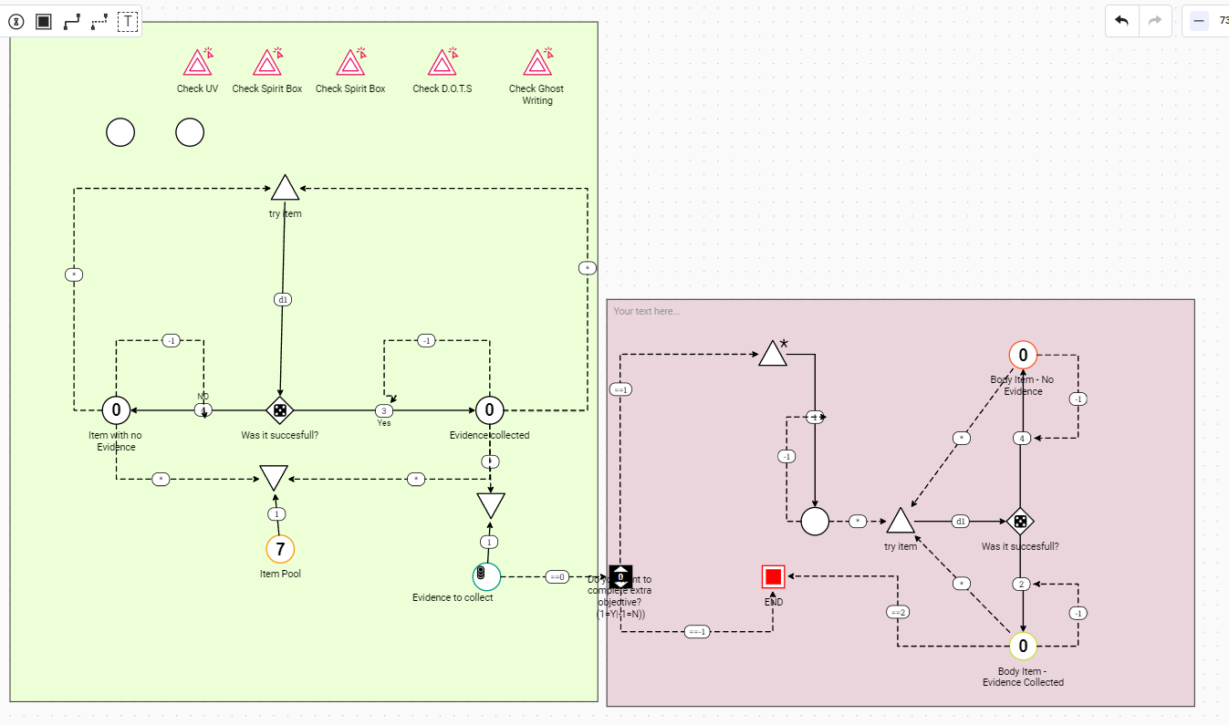
Screenshot below represent two stages of the prototype. At this point the prototype shows just the functionality of the original game, without implemented system that I created. This second version allow to “play” the prototype and more or less, get familiar with the game.
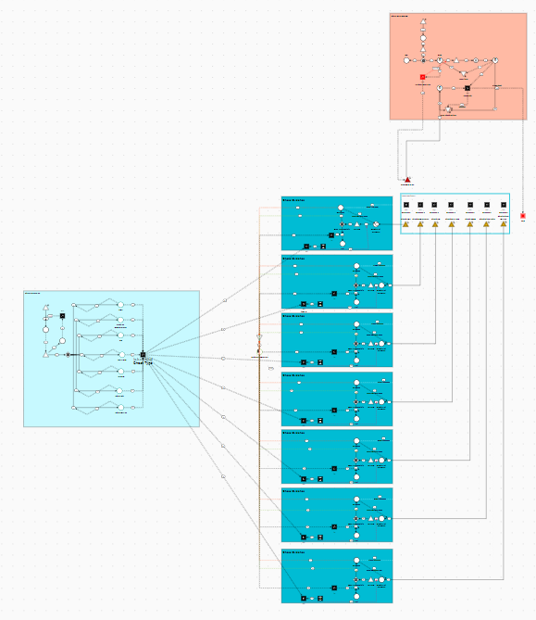
New Gameplay Prototype:
The screen shot below represent the final stage of the prototype. It shows the full size of the prototype. The later screenshots represent its components.

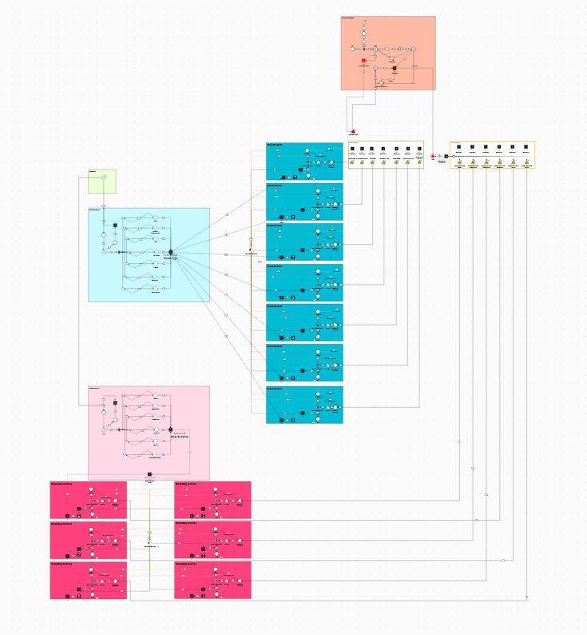

Evidence of Prototype
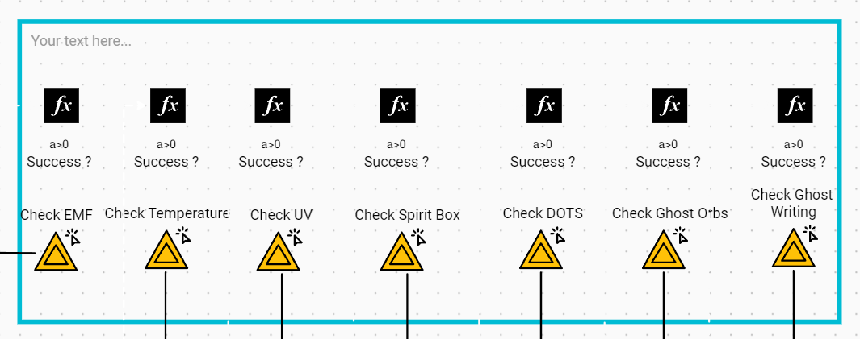
User Input:
User input is part of the prototype that is visible for the player. The player can press the buttons to check evidence of the specific item. The response is represented by the function node above the button. The true means that evidence is founds “false” means no evidence found.
Because just like in the game there is a chance for successful response, player should try the item couple of times.
Evidence Check Node:
Evidence check node is part of the prototype that handles the user input from the buttons, calculate the chance of success and if the result was positive check if the items used is part of the ghost evidence.
There are multiple evidence nodes in the prototype. Each one is assigned to one item.
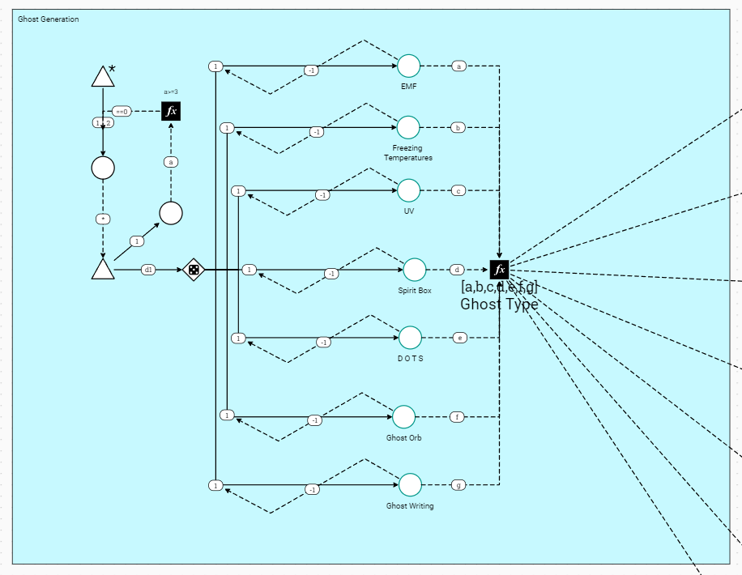
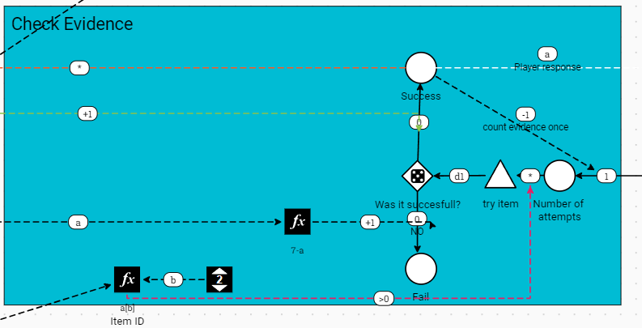
Ghost Generation System
Ghost Generation system is part of the prototype that is being triggered after hitting play button. It creates the evidence for the ghost and save it in form of the array that can be used later by the Evidence Check Nodes.
Each evidence can be added to the array just once, what result with always having three unique evidences inside the array.
Ghost Huning System:
Ghost Hunting system that is being trigger form start. It calculates the chance of hunt and in case of success to inform the player by highlighting the button RUN AND HIDE.
To continue the game player is required to press the button couple of times. If the action won't be performed the game is over. The bigger amount of time the button will be presses the bigger the chance that player will survive the hunt.
Once the hunt is over and player survives the button fades away to indicate the end of an event. It can later highlight again in case of another hunt.
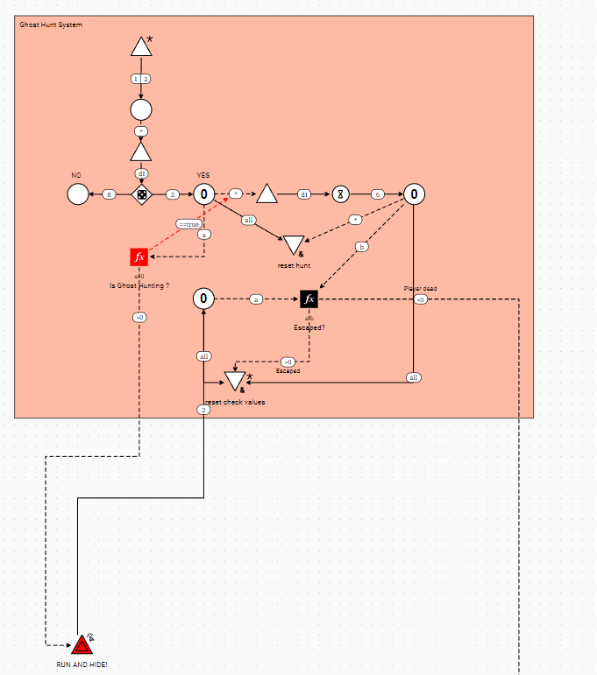
Body User Input:
Just like previous User Input This note is being operated by the player to check the selected type of evidence and provide response.
To activate it user has to first identify the ghost. Next step is to select if player want to continue (which is interactive register). The positive values will unlock the access to the buttons.
Once player found all the body evidence the same register is being used to leave by selecting the negative value.
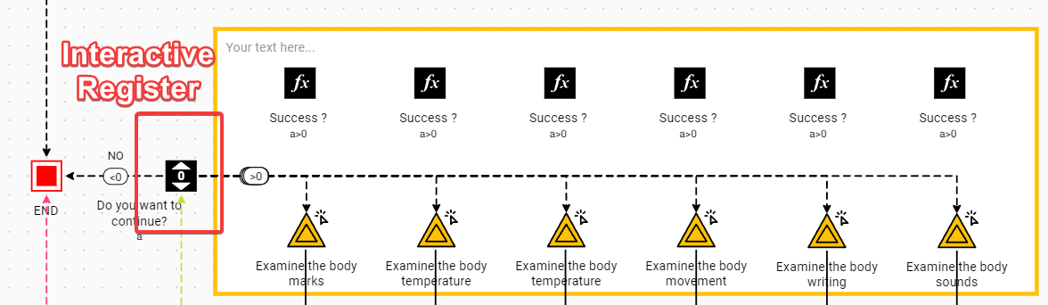
Body Evidence Check:
Just like ghost evidence, the Body Evidence Check Node calculates the chance and check if the response was positive or negative and show it to the player via the User Input Node.
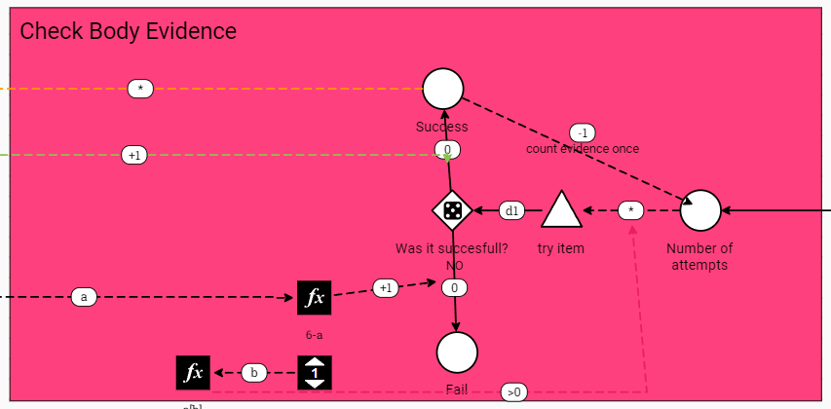
Body Evidence Generation:
Body Evidence generation is being triggered alongside the ghost generation and is responsible to generate the evidence for the body.
It also does not generate the duplicated evidence and save them in form of the array. Where the ghost evidence node generates three types of evidence, the body evidence generates two, what makes it more balanced in late part of the game.
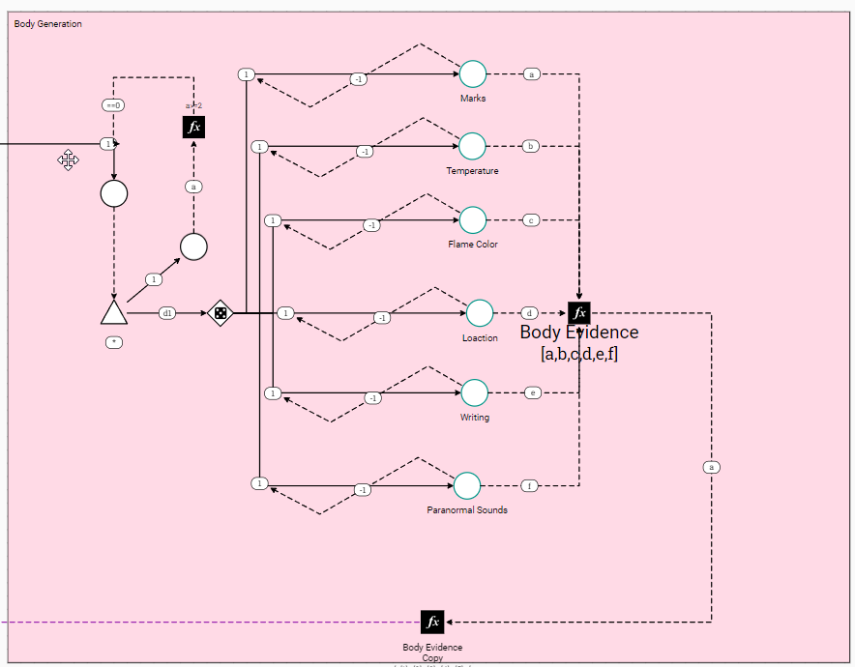

Evaluation / Lessons Learned from Prototype

You document should cover the following:
- Why the systems are designed as they are.
- How the systems support the game concept and the desired player experience.
- How the systems are embodied by the game’s objects as the system parts.
- The goals for this system, expressed in terms of the player’s experience: how does this system help create the gameplay?
- Sufficient graphical depictions of elements of the system.
- What player interactions are enabled or required due to the system.
- List of related subsystems with descriptions.

