Research Report

Filip Lichonczak – l026819k

Contents

Introduction 3

Introducing the research 3

The need to review 3

Describing research Question in detail 3

What the reader gains from this review 3

Presenting study methods 3

Specifying the direction of research 3

Describing the literature review and its criteria 3

Reporting data collection methods 4

Reporting the results 4

The primary studies analysed 4

Experimental conditions used 5

The results observed 10

The results 11

Subgroup results 16

Discussing the results 16

# Introduction

## Introducing the research

This research provide insight into the design process of the gameplay implementation of the open worlds. It should provide optimal experience for both new and experienced players, with keeping the original functionality that builds the game feel.

## The need to review

The need of review of the subject is because a nig number of open world gameplay implementation results with player being led by the game rather than game being explored by the player. It is with included introduction to the gameplay elements.

## Describing research Question in detail

The subject of the research was focused on the gameplay implementation of open worlds. This work is supposed to help to identify the good design practice that will help in identification of the open world type and creation process of the open worlds.

## What the reader gains from this review

Based on the research, reader can find out about the ways of identification of the open worlds and the solutions that help to build and implement the gameplay elements within the open worlds. Among the other this paper explains terms like learning patterns, points of interests and resources; and check their effectiveness in the implemented environment in order to evaluate the best practices in challenge creation and gameplay implementation within open worlds.

# Presenting study methods

## Specifying the direction of research

Because of the type of the tool used for the world creation, the type of the open world was associated with it. Therefore, the world and the gameplay were designed for the open world-survival-horror experience.

The research was concluded with the artefact created with the Dying Light Developer Tools.

## Describing the literature review and its criteria

As mentioned before due to the tools used for the artefact creation the direction of the literature review was created for the open world survival games.

The process of picking references was divided into two stages.

The first stage relied on gathering reference based on the keywords. The keywords include were among others: open world, game design, gameplay design, challenge, challenge implementation, resources, point of interest.

As an outcome the promising techniques for open-world survival games were identified, and described below.

## Reporting data collection methods

For the data collection method, I decided to use quantitative random technique. It should provide equal chances to participants of all genders, age and game experience to provide the generalised result.

# Reporting the results

## The primary studies analysed

Based on the performed research, the following finding can be drawn.

**Resources**

Resources and quest items should avoid giving shining indicators what might lead for the player to look for indicator rather than item itself. That should prevent the situation where player is being “played” by the game.

Additionally, resources should be associated with specific item or location. It will allow for creation of learning patterns that can presented to the player. This should allow for creation of the “tutorial” that will introduce player to the specific type of item, how to recognize it and where to find it.

**Points of interest**

Are the recognizable locations, populated over big environment or open world that contain specific type of the gameplay or utility for the player.

Thay can be associated with the challenge like the boos fight, resource location, enemy outpost or the safe location. These locations should be recognisable to reward the players who possess the knowledge about them and who are looking for them.

**World as part of the challenge**

One of the common approaches for the survival games is to include the world as the part of the challenge. That allows for creation learning patterns that player will be able to use during the game. More efficient with the games that heavily rely on player learning abilities.

## Experimental conditions used

In the artefact used for the testing purposes I used multiple methods that I will describe below.

**World**

One of the key ideas was using the world itself for gameplay implementation and challenge creation. The basic mechanic used for this purpose was parkour that modifies the way of player movement allowing for more options while picking the path to the target.

That required designing specific terrain that will allow for creation of two paths: ground and roof. The ground path contains all the enemy encounters; however, it allows f for access to lootable items and all more interest locations. The roof path allows for fast movement between locations due to lack of enemies but require additional parkour skills. Additionally, the roof path does not offer that many resources as the ground path.

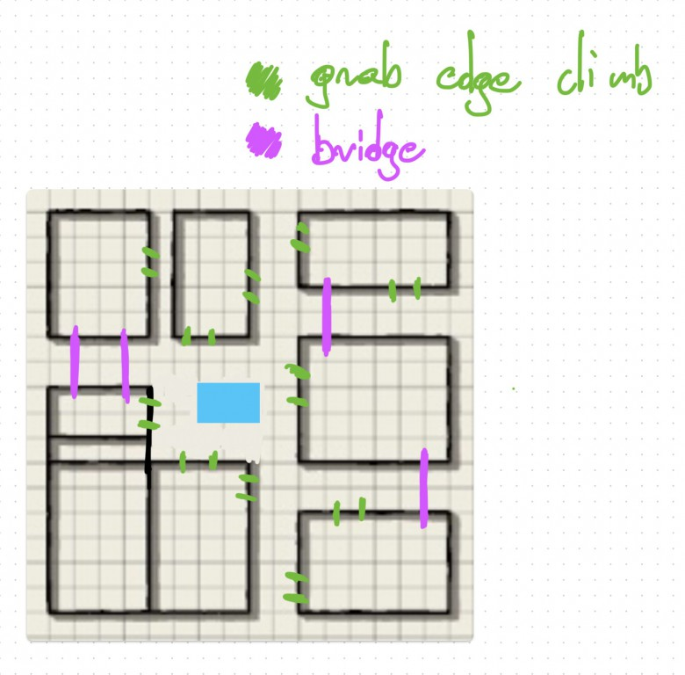

Grab Points / Climbing Locations

Cables / Bridges between buildings

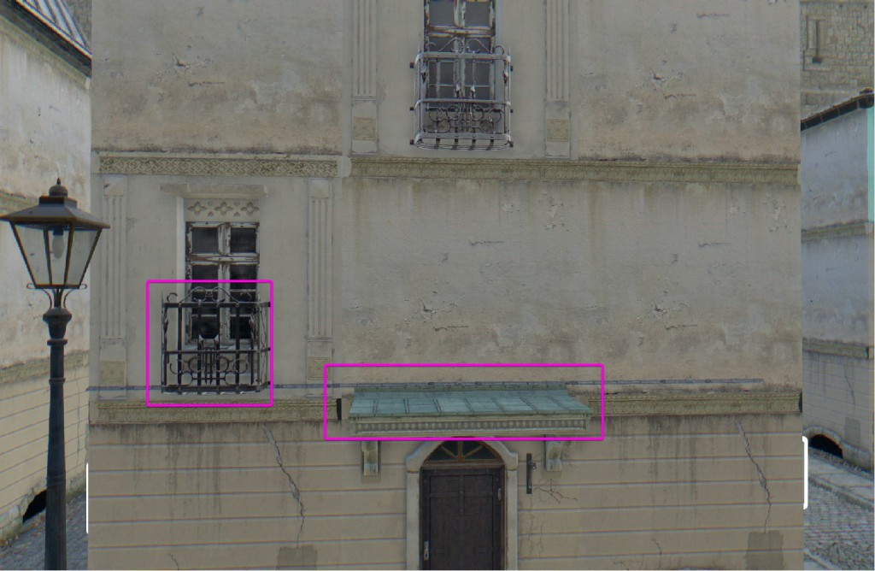

**Quest/Objective** – Players were presented with simple quests about collecting specific type of the resources, without suggesting where they can be. That means there is no visual indicator that is usually present in the original title. That solution had two purposes.

Firstly, it allows for the avoidance of the shining objects or indicators that might create impression that player is being led by the game while playing the game.

Secondly, it allows for creation of the learning patterns that build players knowledge about the game world. That solution should help player to immerse in the game world and reward the players who are paying attention and learning from the world.

In order to create the learning patterns the resources were divided into three categories, associated with specific location or object within the world.

**World Locations**

**Medical Resources**

Medical resources category is being associated with all healing items or items that are ingredients for healing crafting recipes. The items that are included in this category are:

* Alcohol
* Gauze
* Medkit
* Adrenaline

The location where player can find these items are:

* Pharmacy – player can find the items on the shelves, counter, inside the fridge and in the firs aid boxes
* Ambulance – player is able to find big, yellow vans with the “ambulance” text on them. The access to the ambulance might require using the lockpick, what might expose player to the attack of the enemies
* First Aid Box – inside the indoor locations player can find white boxes on the wall, sometimes with the green “first aid” label on them. The boxes can be found close to the exits for the commercial buildings and inside the bathrooms in the living quarters

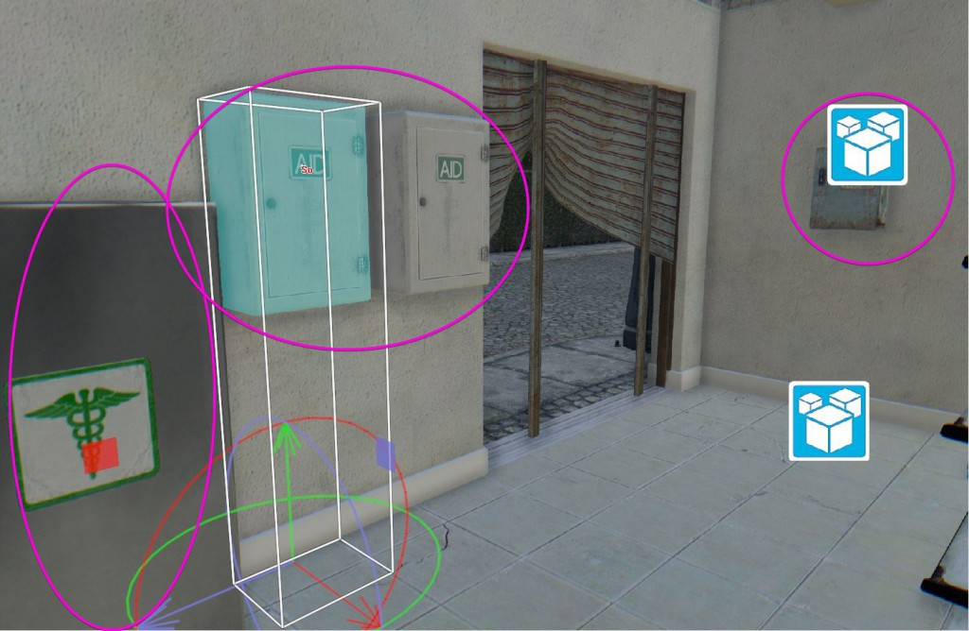

**Crafting Resources**

Crafting resources are items that can be used for the crafting and repairing equipment. They can be found the around the whole world in varied locations associated with technology or crafting. The items associated with this category are:

* Metal parts
* Duct Tape
* Blade
* Nails
* Plastic
* String
* Electronics
* Power cable

The location where player can find these items are:

* Car/Van trunk – around the world player is able to locate cars and vans. The access to them might require using lockpick, what will make player exposed to the enemies’ attacks.
* Fuse boxes – outside of the buildings or inside some of the living quarters player is able to find the fuse boxes. Around them player can find some crafting materials
* Workshops – inside the living quarters player is sometimes able to find the workshop room or location. These locations offer variety of the crafting materials
* Living quarters – inside these location player can explore locations close to the household devices and be able to find some materials

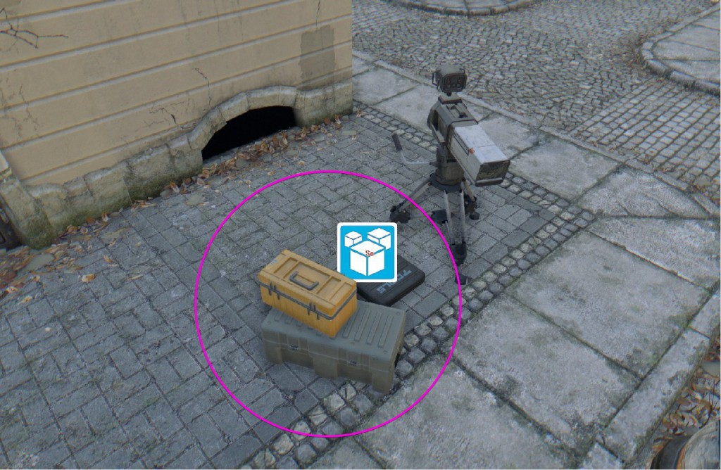

**Food Supplies**

Food supplies are types of the item that can be used either to heal player instantly after collecting them or can as crafting or merchandise item. The items associated with this category are:

* Coffee
* Sugar
* Dried Fruits

The location where player can find these items are:

* Fridge – are located around the world inside the indoor locations and can contain multiple items
* Supermarket – special building / indoor location where player is able to find big amount of food supply items

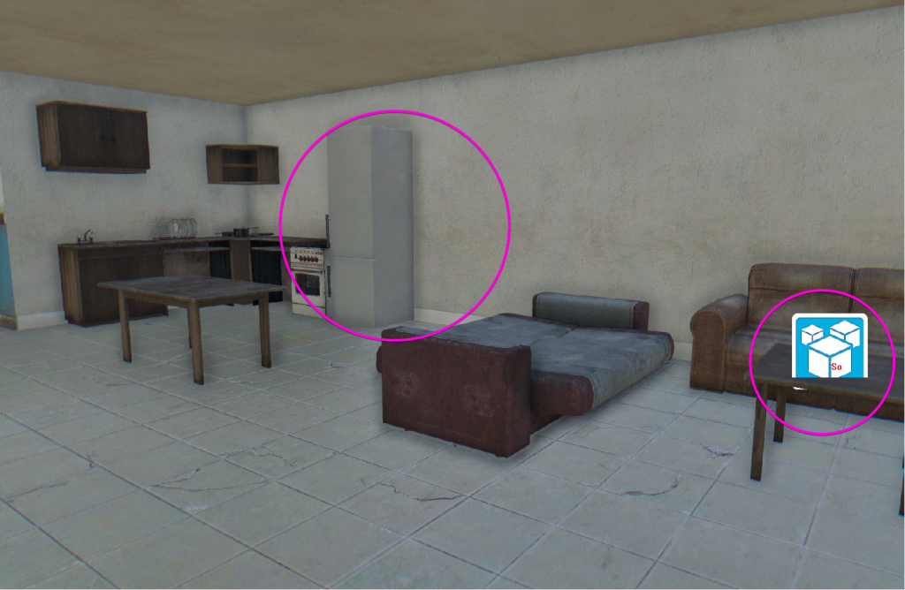

**Herbs / Natural supplies**

Natural supplies are the items that are typically with the green areas of the world and player is unable to find them inside urban / residential areas. They are being used as the crafting material. The items associated with this category are:

* Glowing mushrooms
* Herbs

The location where player can find these items are:

* Old tree trunks – smaller object then the trees, with colour that allow to differentiate them form the regular trees. Player can find multiple glowing mushroom groin on them
* Pines - Higher trees growing the green areas. Can be recognised, especially from the distance, due to their heigh compared to other trees. Player can find the herbs growing around them.

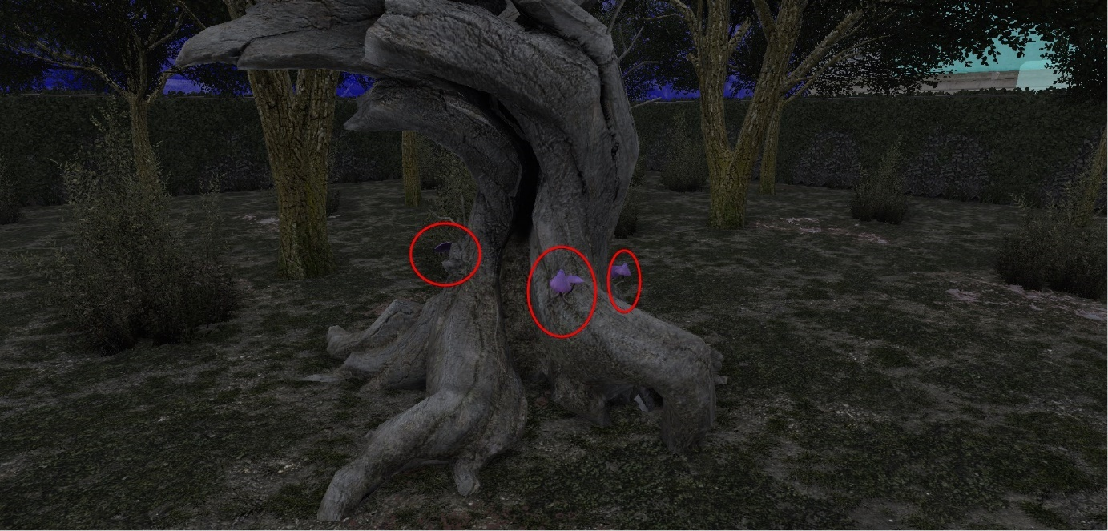

**Enemy locations**

Due to using word as a part of the challenge, the enemy locations were designed to be present od one of to paths. The enemies are present on the ground level around the locations that might be interesting to the player. Therefore, they can be used as the indictor for the play.

The location of the enemies should also motivate the player to look for and use additional paths that will allow to avoid the encounter. This was performed to push player to use the parkour mechanic more.

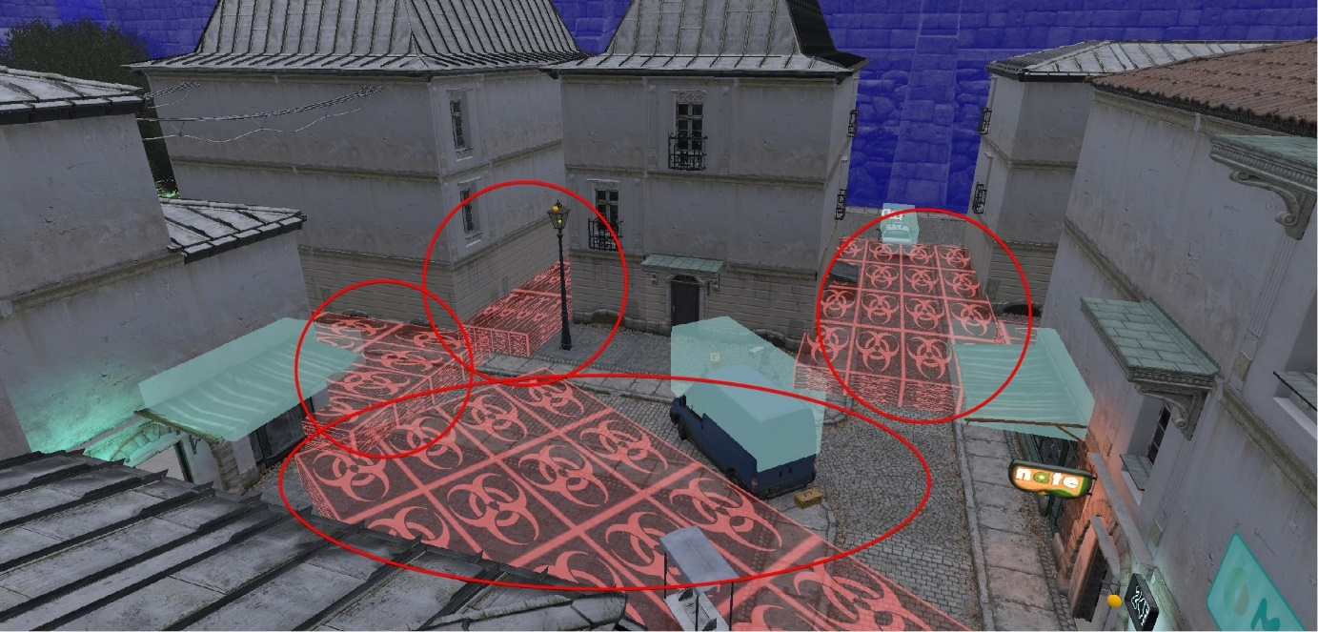

## The results observed

* Most of unexperienced players did not knew how to get back the roof top path.
* Safe zone was no visible enough and was not working the exact way as it in original title, what was confusing the player.
* New players were not aware of the fall damage

## The results

**World Structure**

The result of the playtest showed the mixed responses about the world structure. Some people got confused of because either the structure or the visual appearance of the environment/buildings. Additionally, not all participants were able to find the way back to the rooftops, and small number of pickups push players to explore the street paths more.

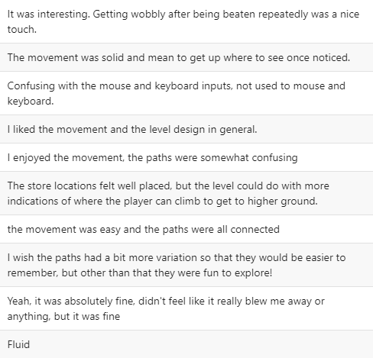

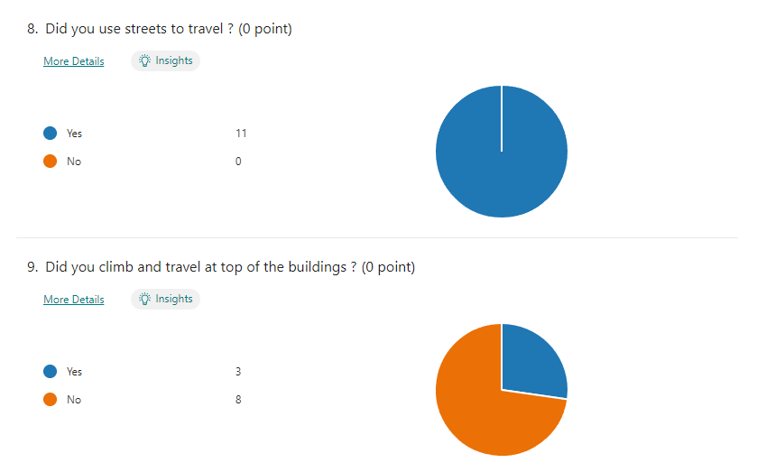

Every tested participant used the environment while dealing with enemies in order to avoid them or to attack them / distract them from the distance. Some participants also use the environment with the parkour mechanic to negate the fall damage.

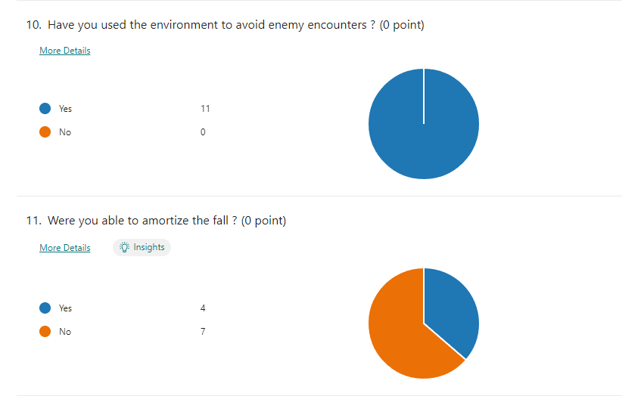

**Safe Zone**

Over 50% participants could not localize the safe zone. Thos who achieved it were able to do by the UV light during the night. That concludes that key locations should contain additional indicator that would signalizing to the presence of the key location.

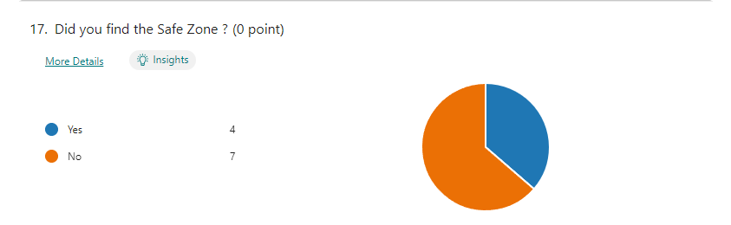

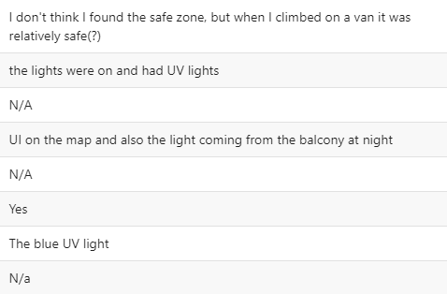

**Enemies**

Enemies seem to provide a good challenge aspect of the game. The were mostly useful guarding access to the points of interest like locked lootable cars or shops. The were easy to fight but be challenging in bigger groups.

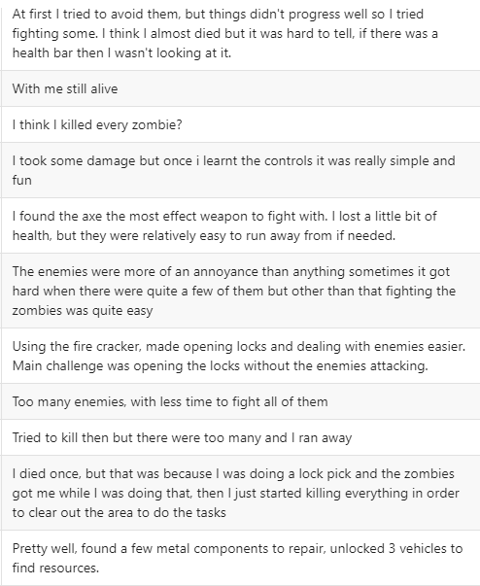

**Resources / learning patterns**

Additional important gameplay of the designed environment was learning patterns for the resources that player can collect. Most of the participants found the locations for the resources mostly intuitive or intuitive.

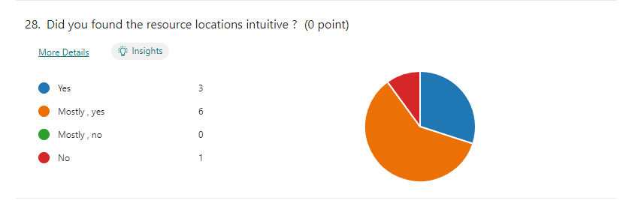

**Healing Resources**

Participants correctly recognized the locations for the healing items. Based on the feedback after playtest session, the exploration of the level helped greatly. Once players knew to what locations they have access the were able to evaluate the possible location of the healing resources.



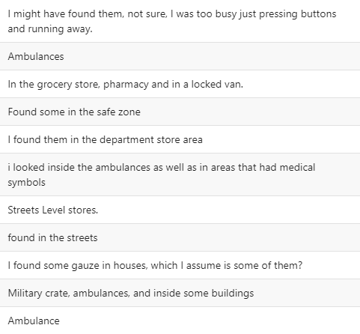

**Food supplies**

Most participants were able to recognize the food supply items, but there is group of 30% that could not find or identify them. That should be fixed by the adjustment of the objects or their locations to create more player friendly experience.

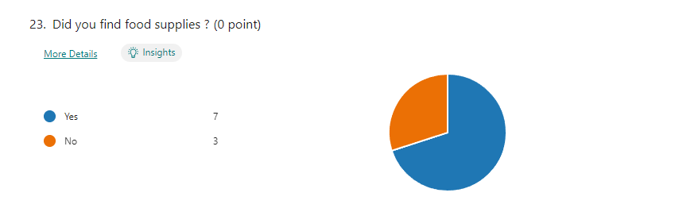

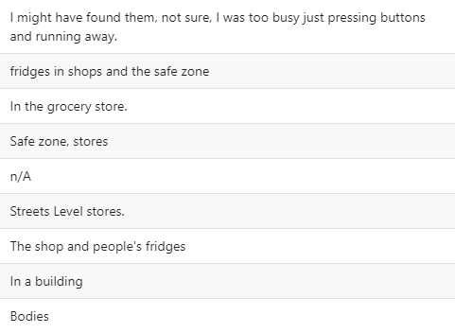

**Crafting items / Metal parts**

The crafting materials were not so obvious for the participants. They managed to find some inside the store areas, but no one mentioned the locations inside the living quarters or the fuse boxes outside the buildings. This locations and objects assigned with the crafting items should be redesigned to support more the learning patterns.

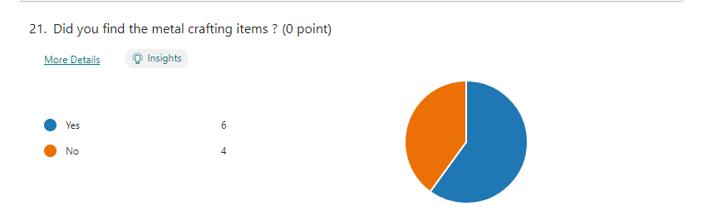

**Natural crafting items**

Slightly over half of the participants found the necessary items. The result is not satisfying; however, some people were able to correctly identify the area, without actually obtaining the resources.



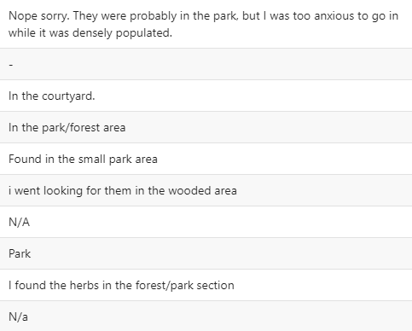

### Subgroup results

**Experience with Dying Light**

For the purpose of the paper, participants can be identified by the previous experience with the original title. Those who possess previous experience are expected to progress through the environment much quicker, parkour more efficiently and find bigger number of the pickups defined in the quest.

The participants with previous experience with game prove to have much more understanding in the game mechanics and were able to identify them more quickly. They were able identify access to the higher location easier and faster and were able use environment more efficiently against the challenges located within the world.

**Experience with open world type of games**

Participants who have experienced previously open world type of the games, are expected to identify learning patterns more quickly than participant without the experience.

Participants who possess previous experience with open world type of games were able to identify pickup locations more often than participants with small experience or without it. Additionally, players with previous experience had smaller issues with getting used to the controls.

# Discussing the results

**Pickups and their locations**

The location indicators did a good job. Based on the feedback, participants were able to recognize the different areas for buildings, stores and park area. The pickups assigned to the locations were recognizable, however not all of them. Some of them did not provide enough guidance for players to recognize them. The time of the playtest, that was between 10-20 min also didn’t allow to fully experience all of the possible learning patterns assigned to the pickups. Participants enjoyed the more natural approach of the pickups and their indicators what was one of the main targets.

**World Structure**

*Parkour*

The vertical locations mostly worked as intended. Participants used them to travel through the world and used them to avoid enemies or as observation point. However, form the responses, the roof top locations should have more gameplay elements, to player entertained. The world structure, should me more recognizable and use some kind of indicator between vertical paths.

*Enemies*

Enemy locations were built in the narrow alleys. As intended it produced fast paced gameplay that increase the tension.

*Player input and tutorial*

The world should be built, and play-tested considering different inputs like gamepad, not just keyboard and mouse. I should also include better introduction to the mechanics and input options.

**Variety**

Multiple gameplay variations allow players to experience the game for longer time and learn about the game world. That result with improved immersion and game feel of the players. The playtest proved that players enjoyed multiple tasks, without direct indicators.

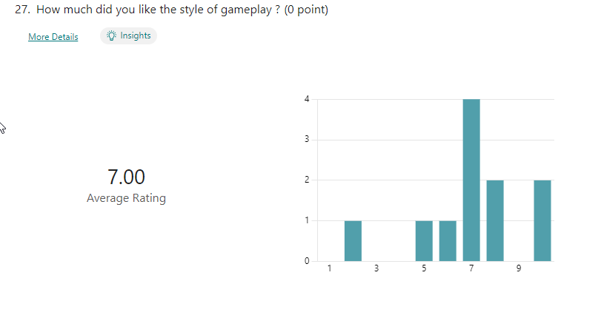

While describing the gameplay the participants responded as:



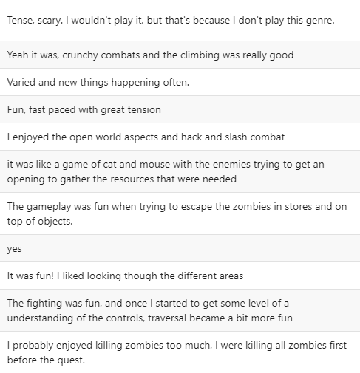

Participants, when asked about improvements related to gameplay, answered with creation more intuitive tutorial. Additionally they asked for more and more specific features related to the specific location, to make them more recognizable from gameplay perspective.



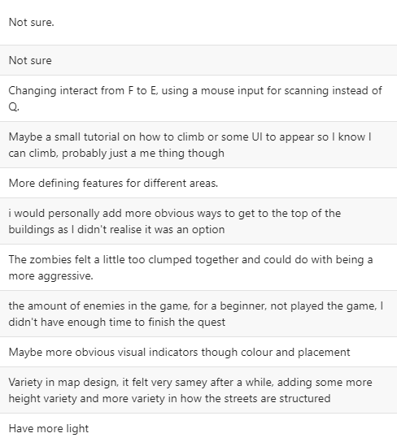

Overall, the final result confirms the usability of the learning patterns in the open worlds. This technique allows for creation of the more immersive gameplay and more interesting experiences by giving player clues that are being used for the gameplay. Additionally, the key locations should keep the visual indicators to help guide the players through the world. The last elements are to make path visible and recognizable, also the vertical ones. That will create the sense of choice by ging player more possibilities to travel through world.